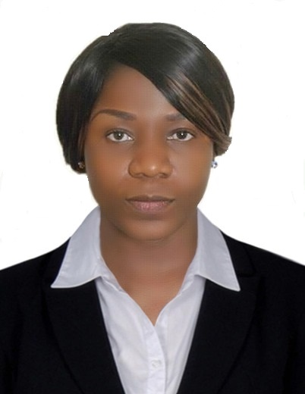
APRIL
C/o 971503718643 .E-mail: april.377930@2freemail.com
Summary
High energymassagestherapy with the knowledge of wide range of massage methods and techniques, able to relate well with staffs and client. Work well in high end and challenging environment, background in resort, spa and hotels.

Highlights

Physically Strong Service minded
Whole body massage Friendly and outgoing
Herbal wraps Stress management techniques
Aromatherapy Enthusiastic
Reflexology Empathetic and patient

Experience
Massage Therapist
Federal Palace Hotel Lagos. Nigeria.2013 -2015

- Consult with client to determine massage needs and special request.
- Recommend additional techniques such as method that client can perform at home.
- Assist in hotel and spa marketing through one on one referrals and networking.
- Perform wide range of massage and therapy techniques
- Consistently increase client satisfaction through skillful service and friendly manner.
- Comply with all procedural guidelines pertinent to massage therapy and interact nicely with guests
- Elicit feedback on given massage therapy and respond accordingly.
Massage Therapist
Spring Massage and Spa. Lagos. Nigeria.2009-2012
- Provide professional massage to guests with 25, 50 and 100 minute prior to appointment.
- Maintain massage room with supplies and ensure neatness across shift.
- Ensure to observe customer reaction to massage as well as modify as required.
- Provide safe, suitable and effectual massage techniques
- Explain method and applicable techniques appropriately to customer needs as well as preferences.
- Learn about precautions and contradictions for massage before every session.
Education /Qualification
Specialist Massage Therapy. Diploma.
John Academy INC LTD.Whitechapel Rd, London E11EW, United kingdom.

Massage technique, Facial, Neck &Back massage, full body massage, Swedish massage,
Hot stone massage. Thai foot massage, Medical and Parental massage, Baby massage,
Sport massage, Trigger point therapy, Reflexology, Indian head massage and Acupressure.
Telepoint Communication Diploma
[Telemarketing diploma Houston Texas USA.2013] Part time Course
[Certified Customer Service, Customer Care training,certified telemarketing]
Itolo Girls Senior Secondary School
[Senior Secondary School Certificate 2004, SSCE]
[West African Senior School Certificate Examination 2007, WASSCE
Certifications and Licenses
John Academy INC LTD. London E11EW,United Kingdom 2018
Spring Massage Therapy. Lagos, Nigeria.2009

Skills
Service Orientation
Interpersonal skills
Communication skills
Customer Service
Marketing Skills
Personal Details
Nationality : Nigeria
Marital status : Single
Date of Birth : 06/04/1986
Visa Status : Resident Visa
References
References upon request.

