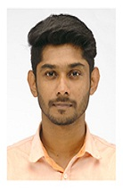
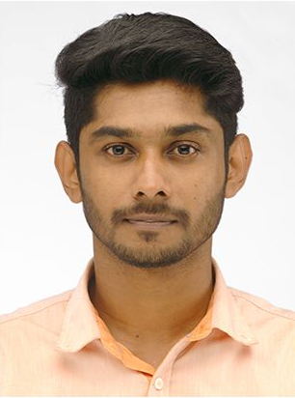
CHRISTIN
Industrial Area 3 . Sharjah
Email: christen.377945@2freemail.com
Contact: _{C/o 971504973598}

CAREER OBJECTIVE

Like to work in a challenging environment where my skills are fully utilized, aids me in professional as well as personal development while gaining a new experience and knowledge.

PROFESSIONAL EXPERIENCE
- Two years experience as Senior Accountant (September 2015 to September 2017) - MS & J Associates, Changanacherry which has responsibilities on Accounting and Financial operations.
Reference : Padmadas K, Chief Financial Manager, MS & J Associates
Phone : +919495848503
- Four months experience as Chief Accountant (September 2017 to January 2018) at Ayyar & Cherian, Chartered Accountants,Kalathipady, Kottayam
Reference : Josy Thomas FCA, Chartered Accountant, Ayyar & Cherian
Phone : +919447051686

JOBRESPONSIBILITIES
- Day to day accounts and monitoring of each and every transactions.
- Participation in firm and individual audit at various client premises, involving vouching of ledgers, documentation and file management.
- Preparation of accounts in Tally.ERP 9.6
- Independently handling GST and Income tax, preparation of Manufacturing, Trading, Profit and Loss Account and Balance Sheet.
- Provide market competitive information periodically.
- Participate in sales management meetings to review status of the business.
- Make sure of efficient budget control, fund flow, credit control.

PROJECTS
- An evaluative study about the banks preferred by youngsters to open their first account
- An evaluative study of DTH service preferred by household with special reference to Kottayam Municipality

ADDITIONAL QUALIFICATION
- Diploma in Computerized Professional Accounting(Tally)
- Practical Accounting( certified)
- The Basic Catechetical Training Course
ACADEMIC QUALIFICATION

Course | Board/University | Institution | Year of Passing
M.COM | M.G University | St.Berchmans College | 2015
B.COM | M.G University | St.Berchmans College | 2013

IT SKILLS
- MS Excel | 2009 to Present
- MS Word | 2009 to Present
- MS PowerPoint | 2010 to Present
PERSONAL DETAILS
Date of birth : 24-07-1991
Visa Status : Visit
Nationality : Indian
Languages known : English & Malayalam
HOBBIES
Travelling and playing badminton.
ACHIEVEMENTS
- Represented SB College in state level seminar on Derivative Instruments and Indian Financial Market, organized by Kuriakose Gregorios College, Pampady.
- Coordinated Management Fest, “CAUSERIE” for the year 2012-2013, conducted by the Department of Commerce, St. Berchmans College Changanacherry.
- School topper in plus two (commerce).

DECLARATION

I hereby declare that the information given above is true to the best of my knowledge and belief. If I get this opportunity assure you that I work sincerely to meet your expectation.

Place: Sharjah
Date: CHRISTIN

