SHIBIN 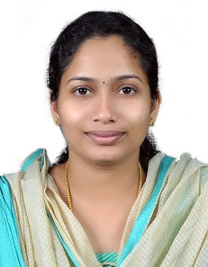
C/o- +971504753686| shibin.377963@2freemail.com │Husband visa

Objective
Looking for the best opportunity in a globally accepted organization where I would be able to utilize and enhance my potential while being resourceful, innovative and flexible.

Education

B tech ece| 2016 | bmce Sasthamkotta
- Marks: 75.53%
- University: Kerala University
- Main Project: Tyre pressure monitoring system

advanced dotnet technologies | 2016| keltron
- Grade: A+
- Web design and development, windows application development

Skills & Abilities
- Good knowledge in MS office, MS PowerPoint& MS Excel and can handle admin tasks
- Data entry skills such as high accuracy and good typing speed
- Excellent teaching skills in subjects such as electronics, biology, physics and mathematics
- ASP.NET with C#, HTML, SQL Server
- Ability to multi task and meet deadlines
- Event management skills

Activities & interest
- College representative in Leadership training campaign conducted by Kerala university
- Active participant in National service scheme at school level
- Enthusiastic to learn emerging technologies and innovative ideas

Personal profile
- Date of birth : 31-08-1994
- Nationality : Indian
- Languages known: English, Hindi, Malayalam

