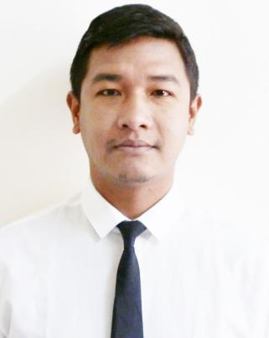
WANGYAL
C/o-Mobile No : +971503718643
Email Address : wangyal..377966@2freemail.com
Address : Burdubai, Dubai

Objective:
To work in a challenging and dynamic environment, expect to make a positive contribution and desire to grow with the organization and become an invaluable asset for it. To obtain a position that will enable me to use my strong organizational skills, educational background and ability to work well with the people.
Key Skills And Competencies:
Excellent written and verbal communication skills
Goal-oriented and Good Judgment
Initiative , problem solving skills and multitasking
Willing to stretch extra hours to complete assigned work
Exposure to Windows Operating System and Microsoft Office and MS Excel.
Educational Qualification:

2010 Bachelor of Arts (Hons. Sociology) North Bengal St. Xavier’s College,West Bengal
core subjects were Sociology, English, History, Alternative English and
Environmental Science.

2007 Indian School Certificate (10+2), Delhi Board of Education, Saptashri Gyanpeeth, India.

2005 Indian Certificate of Secondary Education, Delhi Board of Education, Saptashri Gyanpeeth, India.

Work Experience/Internship:

February 2011 – March 2013
Front Office Executive Hotel Silver Oaks, Kalimpong
- Making Room Reservations as per customer requirements.
- Taking Guest Check-in and helping them Check-out.
- Attending to guest queries and complaint, at the same time ensuring that they have a comfortable and enjoyable stay at the hotel.
- Arranging various local tours and sightseeing.

June 2013 – December 2015 Himalayan Vacation Resort and Home-stay
Darjeeling, West Bengal, India.
Worked as a steward in Himalayan Vacation Resort and Home-stay, Darjeeling West Bengal, India.
Job Profile:
Meeting and greeting guest
Booking guest tables
Keeping restaurant area tidy
Taking food orders
Making KOT
Setting up table

Jan 2015 – September 2017

Worked with Beekay Auto Pvt. Ltd Maruti Suzuki India as a sales consultant.
It is the Leading dealer of automobile in Siliguri, West Bengal, India with three main show room comprising of more than 350 vehicles in stock and more than 15 outlets within the district and the state, with an employee strength of more than 1000.

SALES CONSULTANT

- Sell specific products and services to consumers.
- Demonstrate products and show consumers how to maximize their features.
- Check inventory to ensure product is in stock.
- Conduct outbound lead follow-up calls to potential and existing customers via telephone and e-mail to qualify leads and to sell products and services.
- Ensure the booking has been correctly done with booking amount.
- Pushing sale of accessories and spare parts.
- Adjusting displays as needed.
- Ensure pricing is correct.
- Making planners sheet for field visit and follow ups.

Extra-curricular Activities:

- Active member in inter-school and College elocution, debates and sports
- Member of the Cancer Aid Society where I participated in medical and social welfare camps held by Nationwide Cancer Control Program-me.
- Participated in the training for Awareness program-me on Co-operation for Students, conducted by the Centre for Co-operative Management, Kalimpong, India.
- Participated Voluntarily in Program-me of Young Energetic Society, working for the upliftment of the deprived sections of the society.
- Participated in several Music contest in school and college etc.

Computer proficiency:

Successfully completed 6 months Basic course for Certificate in Computer Applications from Saptashri Gyanpeeth, Delhi Board of Education. Exposed to windows operating system and MS Word and MS excel.

Personal Details:

Date of Birth : 20th December, 1990
Nationality : Indian
Languages Known : English, Hindi, and Nepali
Marital Status : Single

