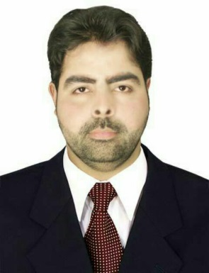
CURRICULUM VITAE

Objective:>>
A highly talented Civil Engineer with over 16+ years of experience in planning, designing, detailing and coordinating with multi-disciplinary teams and executing of projects. Great familiarity with local building bye- laws & other regulatory frame work dealing with built environment and remarkable expertise in client servicing, contract negotiations, preparation of pre-design documents, zoning and planning issues, cost estimating and budget preparation, tracking project performance and monitoring the team dynamics..

Personal Information: >>
Fahed  1988  Married  Pakistani  fahed.377972@2freemail.com  +971501685421 | Name:  Date of Birth:  Marital Status:  Nationality:  E-mail:  C/o-Contact No:

Academic Qualifications: >>
Exam/Degree
Bachelors in civil Engineering in 2007

Language Skills: >>
Arabic (Excellent)
English (Good Native)
Urdu ( Mother Language)
Courses Skills:>>
Windows XP + 7 + Vista
Office 2003 + 2007
Internet
Auto CAD
Sketch Up 6 + V-Ray
Survey level machine
Total station Leica
GPS satellite survey
Professional Skills:>>
• Over 10+ years’ experience in Libya
• Excellent working knowledge of computers, proficiency in the current version Auto CAD
systems.
• Solid organizational, planning and problem-solving skills.
• Broad-based, professional level of construction management experience.
• Excellent interpersonal skills to effectively work with clients and outside consultants to
communicate the impact of design alternatives; negotiate agreements with outside
design consultants and construction contractors.
• Possession of strong product, technology knowledge.
• Proficiency at effectively structure and manage cross- functional project teams.
• Ability to provide over-arching results, recommendations, and documentation.
• Excellent interpersonal and communication skills.
• Ability to follow instruction from team members
• Ability to delegate tasks through clear and concise communication to junior team
members.
Experience: >>
Civil Engineer in CKG Construction Company.  Responsible of Site and stores and managing the work schedules and inspection of buildings and housing units. Also supervision on supervisors and foremen.  Executive Manager in Wide Bridge Construction Company  Managing all the matters of the company and in charge of all the departments of the office and holding the meetings and signing the new contracts and visiting the sites to check the weekly work done.  Construction Manager at Qawafil Africa company  Managing site and meetings and inspection of the work on site.  Site Engineer at Albaid Al-lanuuf Company for oil field services  Incharge of whole sites and works. Managing work schedule and progress with supervisors and foremen and attend meetings and inspection of work.  Construction Manager and sites Manager and partner in HandesaAl.mutatawera company  Full sitesin charge and manage the working schedule on the sites and attend meetings and inspection of all works and supervising H.R and Finance department. | From: December 2007 to July 2009  Responsibilities:  From: August 2009 to February 2010:  Responsibilities:  From : 2010 until 2012 :  Responsibilities:  From : 2012 until 2015 :  Responsibilities:  From August 2015 until now :  Responsibilities:
Note: I also have experience letters from all my worked companies

