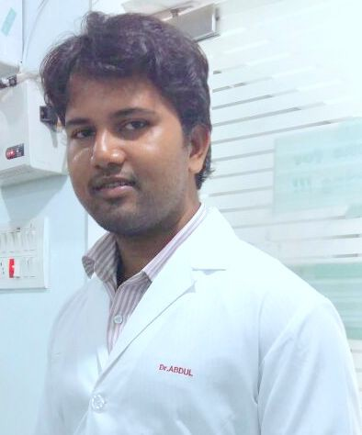DR. ABDUSSU
.
E-mail: abdussu.377986@2freemail.com
Mobile:
C/o 0501685421
BACHELORS OF DENTAL SURGERY (BDS GRADUATE), FAGE(MANIPAL)
BDS Registration number at India: A - 19853
DHA Eligibility letter as GENERAL DENTIST

OBJECTIVE:
4 years of working in the dental field has resulted in a combination of related competencies, including all phases of four handed dentistry. Able to handle a great variety of tasks and responsibilities, simultaneously and effectively. Highly organized, trainable and adjust well to all environments. Possess the ability to create and present an excellent image of the clinic and its service to patients, to coordinate and communicate effectively and efficiently meet objectives.

PROFFESSIONAL EXPERIENCE:
4 Years as a General Dentist With Dr. M. Satish Chandra Naik, MDS – Orthodontist and Implantologist at SAI SHRESTA DENTAL COMPLETE ORTHODONTIC AND IMPLANT CENTER,
Hyderabad. From 30/09/2014 to 08/02/2018 My responsibilities:
- Treat exposure of dental pulp from the pulp chamber and root canal.
- Do tooth preparation on simple and complex tooth structures
- Do simple and complicated tooth extraction procedures following suturing techniques.
- Examine, diagnose and provide treatment counseling to patients in a comprehensive manner
- Examine, diagnose and provide fixed and partial prosthetic procedures as approved by the local credentials committee.
- Provide medications and enter data in the local workload data reporting system.
- Complete dental record documentation for all dental patients.

EDUCATION AND TRAINING:
Bachelors of Dental surgery:

DR. NTR UNIVERSITY OF HEALTH AND SCIENCES IN 2014.

Fellow of the Academy of General Education: MANIPAL, KARNATAKA , INDIA 2018

ANY OTHER SKILLS:
- Ability to treat molar endo cases, pulpotomy and pulpectomy.
- Ability to treat partially erupted impacted third molar cases.
- Ability to do incisional and drainage procedures.
- Excellent diagnostic skills

PERSONAL SKILLS:
- Good command of both written and spoken English, Hindi And Telugu
- Confident and hard working
- Positive approach
- Sincere
• MS Office / Excel 2007/2010/2013
- Adobe Photoshop
- Ability to handle different type of patients

PATIENT: Ms. Carole

Patient aged 26 years came with chief complaint of broken filling and pain in lower left posterior region.
O/E – broken silver amalgam filling was seen with underlying decay in 36. Intra oral periapical radiograph (IOPA) revealed caries invading pulpal tissue.

Patient was advised to go for root canal treatment, which she agreed with and the treatment was completed in a span of 3 appointments.
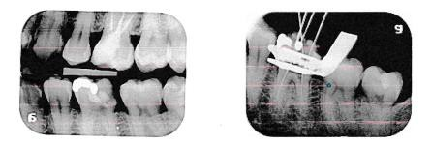
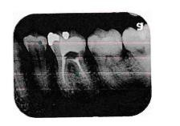

PATIENT: MR. PRAVEEN

Patient aged 34 years came with chief complaint of pain in lower anterior teeth O/E – Attrition, along with tender on percussion and sensitivity with 41
IOPA revealed periapical abscess in relation to 41.

Patient was advised root canal treatment with 41, to which he consented. Root canal treatment was completed in 10 days.

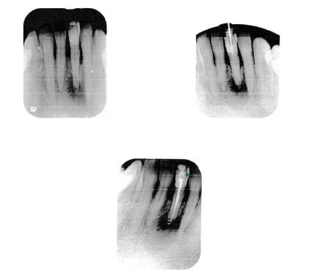

PATIENT: MR MUBEEN

Patient aged 43 years came with chief complaint of pain in lower right posterior region.

O/E – Crown in relation to 46. IOPA was taken to check stats of 4, which revealed periapical abscess.
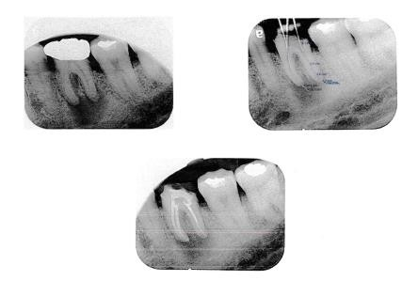
Patient was advised crown removal followed by root canal treatment for 46. Patient agreed and treatment was completed in 4 appointments

PATIENT: MR CHINNA

Patient aged 42 years came with chief complaint of pain and swelling in upper right posterior region.
O/E – Abscess in buccal vestibule in relation to 16, 17.

Advised abscess drainage under local anesthesia. Patient agreed to the treatment plan and was called for follow up after 7 days.

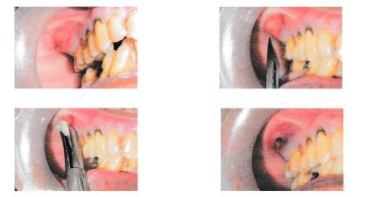
PRE OP:

POST OP:
