Age:

40 YEARS OLD

Date of Birth:

JUNE 13, 1977

Place of Birth:

PAGSANJAN, LAGUNA

Height: 5’6”

Weight: | 130 LBS.

Nationality: FILIPINO

Civil Status: SINGLE

Gender: MALE

Religion: CHRISTIAN

(EVANGELICAL-PROTESTANT)

Permanent Residence / Country

- PHILIPPINES

College Degree

- BACHELOR OF SCIENCE IN INDUSTRIAL TECHNOLOGY

Present Residence Abroad / GCC Country

- SAUDI ARABIA (KSA)

Overseas Filipino Worker : YES!

Motto:

“LET US DO OUR BEST,
TO BE THE BEST”
Objective:

To work in Globally completive environment on challenging assignment with rapid professional growth which will afford me an opportunity to effectively utilize my abilities for continuous value addition and growth along with the organization, so as to contribute maximum to the concern I work for.

ROMEO
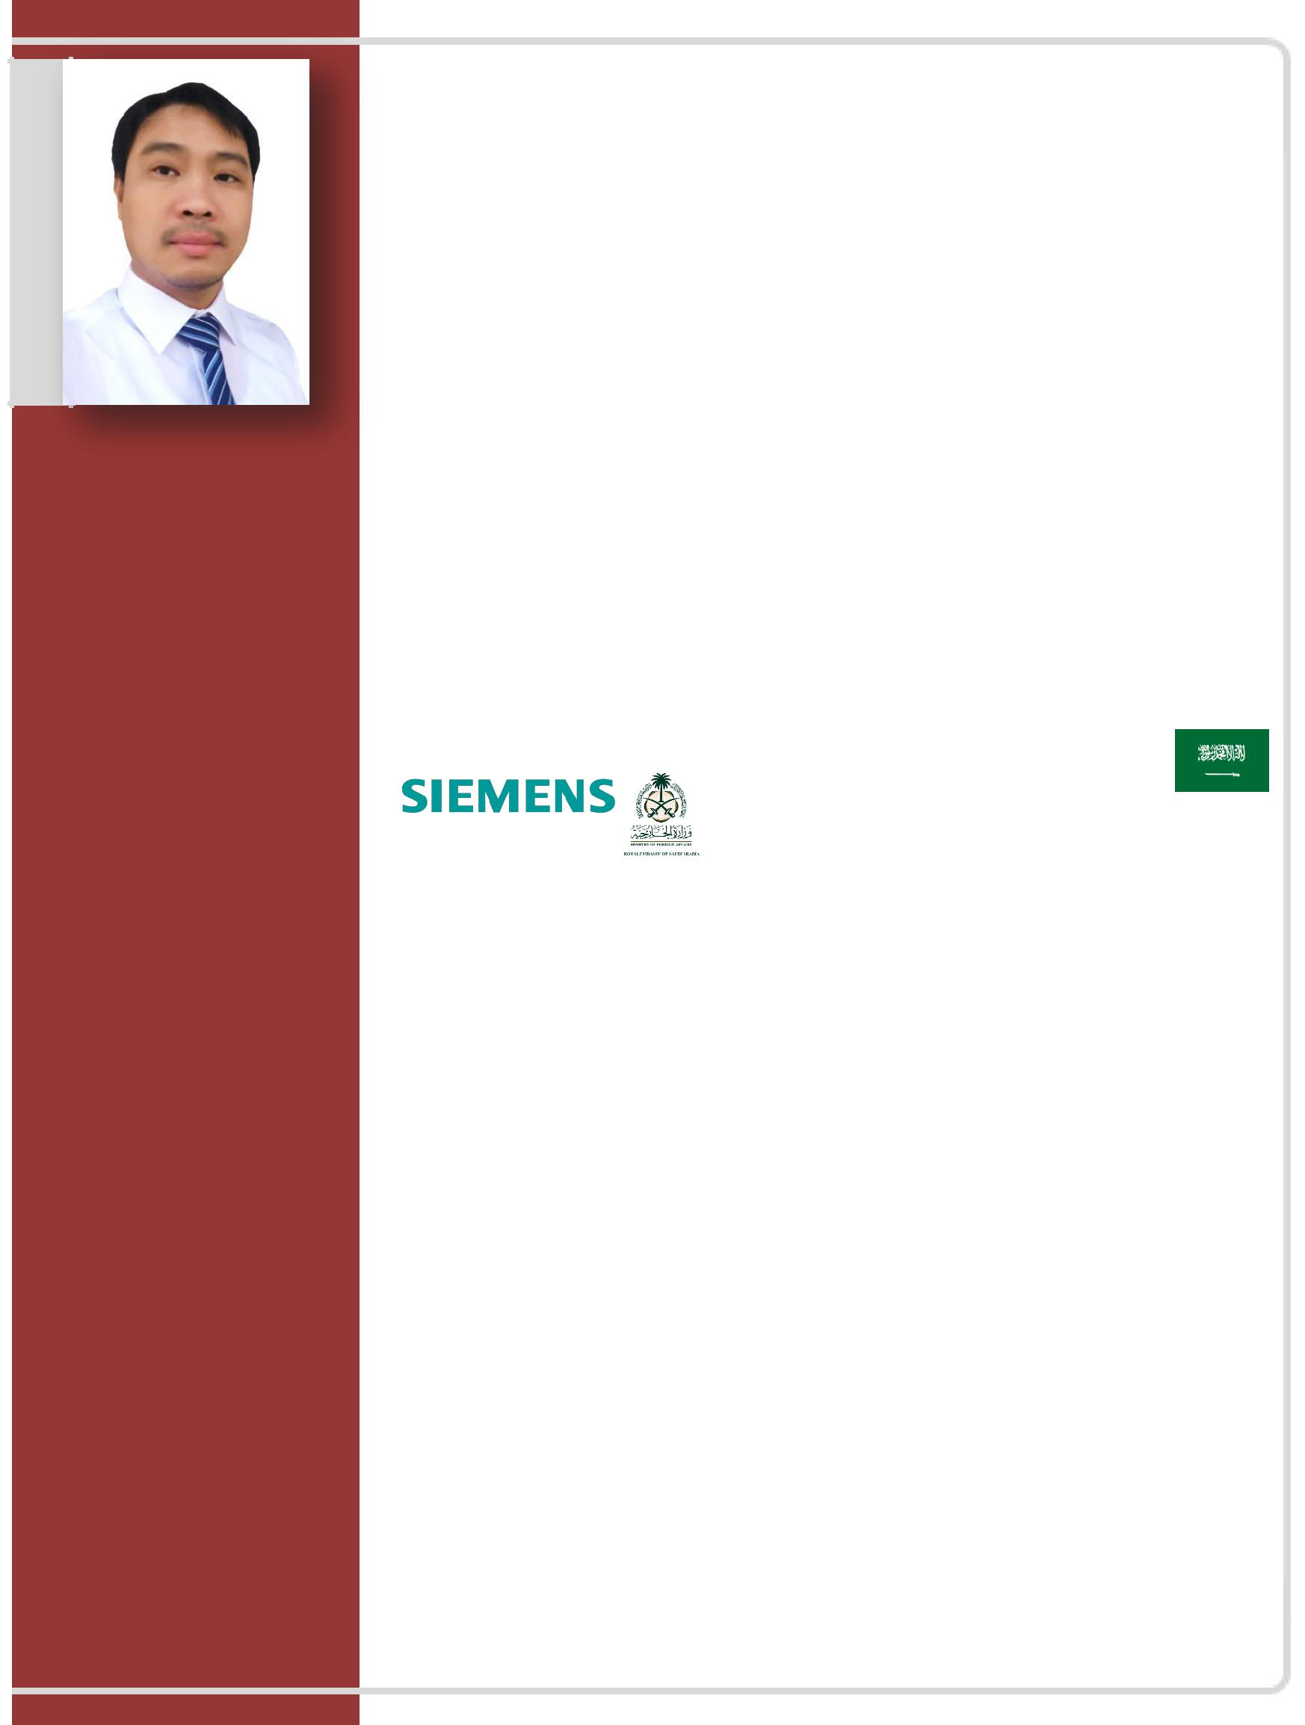
Email: romeo.378008@2freemail.com

C/o-Mobile: +971505891826

APPLYING FOR:

HR ADMINISTRATOR / DOCUMENT CONTROLLER / TECHNICAL-IT SPECIALIST

CAREER SUMMARY:

I have been working in Administrative and Technical profession with over (15) Fifteen years’ experience in property documentation, inventory, communication support system/outsourcing or cooperating with organization development and also in electro-mechanical and low current systems installation, operation and maintenance. My positive work ethics had been proven over the years working with diverse people and cultures varying from bottom level to top management level. I am a hardworking and trustworthy person striving for excellent and effective work performance output to contribute with the company success and endeavor. I look forward to a long term employment and career development experience.

PROFESSIONAL EXPIRIENCE:

Company: SIEMENS LIMITED, SAUDI ARABIA
Status: Overseas Contract Worker (OFW)
Address: Business Gate, Building C-1. Airport Road,
5-YR, 2013-2018 Qurtubah District. P.O. Box 9510, Riyadh 11423. Site Project: MINISTRY OF FOREIGN AFFAIRS (MOFA)

>HR Administrator / Document Controller (HR SPECIALIST)

My function includes provision of Administrative and Property Services to the Client.

- Review, Analyzed, Received, Issued, Updates and Keeping of all the necessary project documentations such as Tender Specification, Transmittal, Job-Order, Tender Drawings, Technical Report, Evaluation Report, Official Letters, Data Sheet, Design calculations Etc.

- Compile and Upload all necessary documentations in the property data center server DMS (Document Management System)

- Provide the ability to control the documentation flow, filing/archiving and document handover activities for the project sites, both for the Head Office and project sites throughout all phases [Engineering, Procurement, Constructions and Technical Commissioning etc.] of the project.

- Provide a review of all the final documentations being generated in both hard copy and electronic version by project sub-contractors and supplies in order to ensure that all contractual requirements will be met.

- Using of FTP (File Transfer Protocol) Electronic Server Microsoft Office application for sharing Document related to the project.

- Report and Process day to day liaison with Project Manager, Engineers and Records supervisors to ensure efficient and effective control of all project documentation from any source either generated internally or externally.

- Process DMS-ODC (Official Document Control) codes and Support the Tender Team in preparing Technical and Commercial Proposal of the projects.

- Control Technical Document Register (TDR) to ensure the status of all technical document until getting the approval and control, filling/archiving correspondence, Tender Drawing and Technical Document, Invoice and Performa invoice, Technical and Commercial Proposals, Pre-Qualification and other company official non-technical documents.

- Responsible for day-to-day Document Management workload.

- Support Technical Team in other section/department.

- Perform documents control duties, which includes: registering all the incoming and outgoing correspondence, transmitting tenders/drawings/technical report/official letter/evaluations etc.

- Can provide daily admin roles as well as project division secretarial roles to the project team and department for proceeding efficiently and without difficulties during the operations.

- Responsible for managing emails, queries and distributing to the concerned personnel for their information.

- Coordinate all progress report/s from projects and submitted to each property coordinators or head dept., daily or weekly progress report and project schedule.

- Prepare expense report such as for Business Trip/Travel, Project Order and other personnel matter.

- Provide other related document such as Tenders, Transmittal, Drawing and other specification need during audit.

- Responsible in monitoring stationary inventory, Supplies and other purchasing order

- Maintain confidential records and files.

- Distribute the entire technical document issued by the Contractor to all relevant Engineers as well as dept. heads.

- Ensure document submissions are complete and accurate as per the engineers’ response.

- Monitoring specification and technical document to ensure accurate Document tracking and to meet project deadline.

- Effective follows the Company’s (SOP) Standard Operating Procedure in submissions of document standard

- Monitoring daily Time track records in the biometric system and making general report (Daily, Weekly manpower report, Employees absent report, man-hour’s summary.

- Maintaining files for Timekeeping records (Sick / Vacation leave / Emergency leave / Business Trip / Resignation / Termination / Transfer etc.)

- Computes total time worked by the employees, posts time worked to master time data and routes time track records to the payroll section/department.

- Updating & keeping in attendance records of employee’s Medical Certificate / Sick leave and also do coordinating employee’s attendance concern.

- Assist, Arranges and compile the document of the new hired employee’s., prepare and issued Company I.D. / Security Access Card, / Uniform / protocol safety dress code.

- Register the new hired employee’s in the Biometric System and also monitors daily time track records system error.

- Prepared gate pass such for (New employees / Visitor / Equipment, Materials, Mobiles, etc.)

- Process day to day liaison outside such for employee’s Visa, Official Letters and other protocol matter.

- Monitor office supplies and preparing protocol for the material needs for the staff.

Company: OCS INT’L FACILITIES SERVICES, QATAR L.L.C

Status: Overseas Contract Worker (OFW)
Address: PO BOX 55624 Doha, Qatar

2-YR, 2010-2012

>Technical Specialist

A Real Estate Property Project: LES ROSES 1 AND 2 COMPOUND (154 VILLAS AL WAAB)

LES ROSES RESIDENCE HOTEL ( 7TH Storey ) APARTMENT BUILDING AL SADD)

LEGEND SUITE HOTEL – APARTMENT BUILDING ( 89 FLATS NAJMA) NAJMA1 BUILDING (48 FLAT NAJMA) NAJMA AREA NAJMA DOWNTOWN DOHA HOTEL (N.D.D.) BLDG.(8th storey’s)

- Monitoring of operation and maintenance of electrical equipment’s such as power station with maximum KVA rating, pump station, fire pump station, and generator set.

- Repairing of electrical supply and utilization of equipment’s including switchboard, control panel, and installation of DBS, MVS, MV breakers, etc., for modification if necessary.

- Coordinating with the chief engineer for the installation of new devices and equipment’s which shall be incorporated into the work/project in accordance with the approved plans and specifications.

- Analyzing and evaluating of unusual vibrations, noise, smell, visual manifestations, and data of monitoring equipment’s.

- Installation of CCTV camera, Satellite dish, Cable wiring, (programming /configuring)

- Periodic checking and testing of electrical equipment.

- Replacement of unreliable or aged components.

- Minor repair of malfunctioning equipment.

- Keeping of complete records such as directory panels, circuit breakers, switchboard, switch gear, and maintenance history.

- Analyzing inspection and test reports.

- Planning and development of PMS (preventive maintenance system).

- Reading and metering checking of line current, voltage, batteries, etc.

- Monitoring the performance of electrical equipment and devices, and making adjustments if necessary.

- Responding request for emergency replacement of defective electrical component such as bulbs, lighting fixtures, electronic devices, etc.

- Performing maintenance duty for villas and other properties like condominiums, apartment and other commercial buildings owned by the company.

- Repair kitchen appliances such as Microwave Oven, Washing Machine, Dyers, Gas range cookers and also other electrical equipment like CCTV, Fire Smoke Alarm system, Exhaust fan and Audio, Video system, etc.

- Repair Street Post Light, Side wall light in common area’s

- Operate BMS data program CMMIS (Computerized Maintenance Management Information System)

Company: REMEC BROADBAND WIRELESS LLC (Phils.)
Status: Regular Employment

Address: Carmelray Industrial Park 1 (CIP1)
Brgy. Canlubang - Calamba City, Laguna

3-YR 2006-2009

>RF Test Technician

- Receive works descriptions from superior and provide technical support to production in such a way that it yields, and the labor efficiency is continuously achieved and improved.

- Operate and teach the knowledge on technical aspect in the production such as circuit boards, processor chips, electronic equipment, and computer hardware and software, including applications and programming.

- Follows other related duties as assigned.

- Operate and teach the knowledge of machines and tools, including their designs, uses, repair or trouble-shooting and maintenance.

- Analyze and interpret data and schematic diagrams and work-related documents for technical analysis.

- Perform calibration and repair and test instruments used in product testing & evaluation. Generate the report needed after calibration.

- Check jigs, fixtures, process OSG (Operational Standard Guide) and other requisites of new model’s factory pre-production (FPP).

- Handle and use Automated Test Equipment (ATE) for microwave products like POWER METER CALIBRATOR TESTER, POWER METER CALIBRATOR SENSOR, SCALAR NETWORK ANALYZER, SWEEP OSCILLATOR, POWER GENERATOR SYTHESIZER-SWEEPER, NOISE FIGURE METER, SPECTRUM ANALYZER / OSCILLOSCOPE and other tools use in the production line.

- Check the process or flow in the production line, handle manpower, guide and assist in any fault findings or problem concern, and does production data report.

- Testing, installing, serve replacement of IDU/ODU transceivers in telecommunication base tower or cell site, depending on its frequencies from 7GHZ to 38GHZ of NOKIA Components, SIEMENS, HUAWIE, HARRIS, NERA, SAGEM, CERAGON, MOTOROLA and ZTE.

- Repair, test and troubleshoot RX/TX converter (Transceiver) by BIASING the replacement in the component, read the correct wave frequency signal to check the current and Voltage Standing Wave Ratio (VSWR), ALIGNING, TUNING the tub and other component, and test the overall frequency status after which test it out for HOT and COLD temperature.

- Repairing, Installing, laying, maintaining and configuring telecommunication gear including FIBER-OPTICS cable wiring for indoor, outdoor, (PABX) Private Automatic Branch Exchange system, Control panel board system, Equipment racks, panel board/wiring of LAN & ROUTER.

- Set-up and Assemble components according to manual and utilize tested equipment for evaluation the performance of the transceiver and determine the adjustment.

4-YR, 2001-2005

Company: ISOLA AG ASIA (PHILS.) PACIFIC, INC.
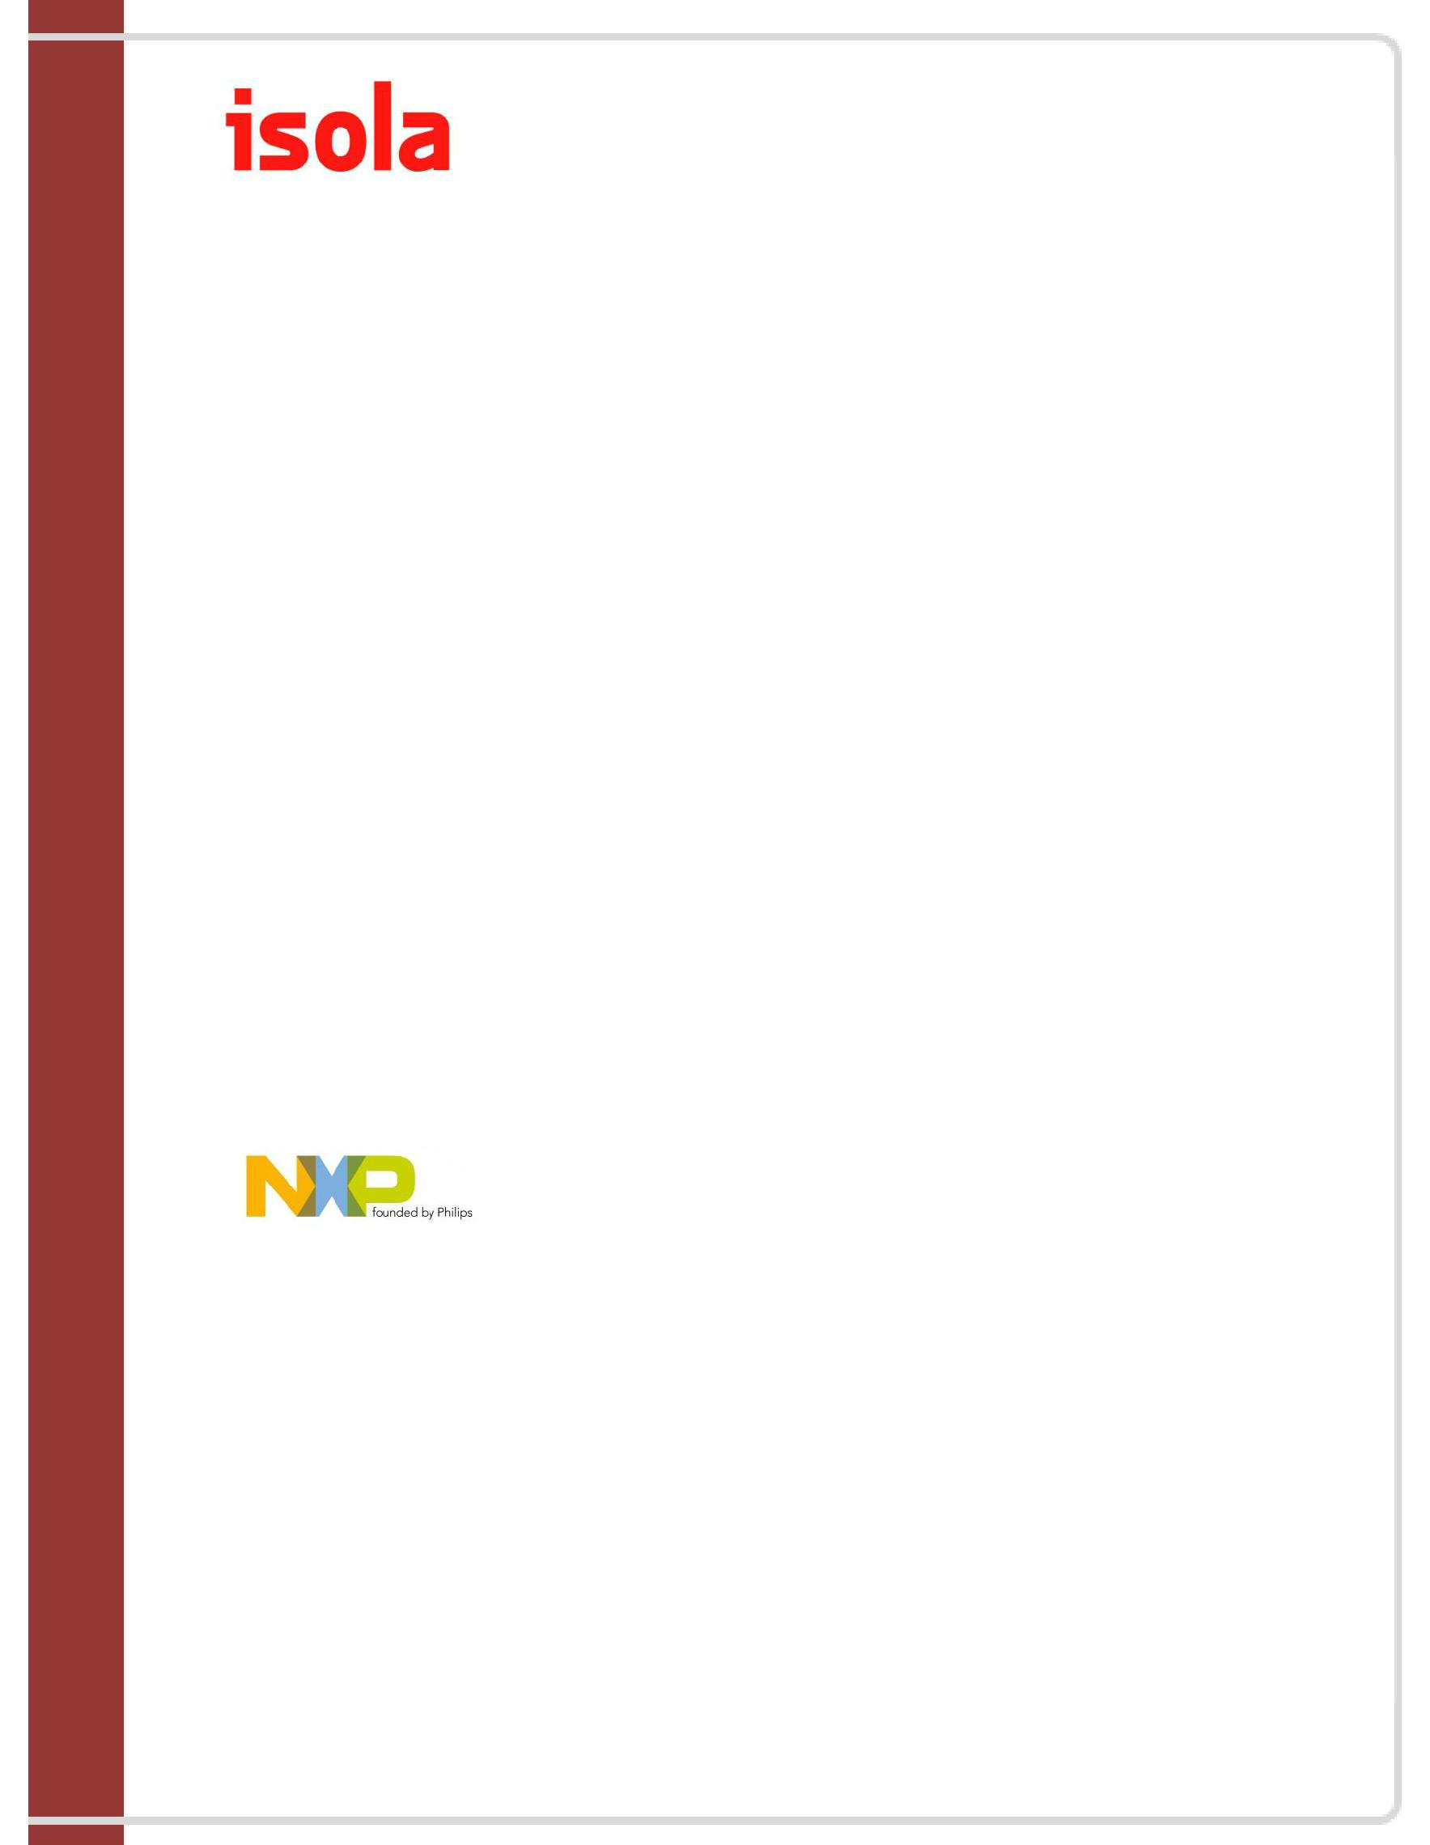
Status: Regular Employment
Address: (FPIP) First Philippine Industrial Park
Brgy. Sta. Anastacia – Biga

Sto. Tomas, Batangas

>Maintenance Technician

- Oversees the company’s maintenance facilities and equipment to ensure smooth operation.

- Coordinates with other department and contractor regarding job order and projects, for the improvement of building, equipment, and facilities.

- Remove and install mechanical instruments, devices used in the machines, programming/set-up and always do perform a calibration.

- Carry out work during shutdown or cleaning.

- Comply with the safety rules and regulations of the company and its employees.

- Responsible for safe and smooth operation of machine which is equipped of PLC Programmable Logic Control and

Computer Numerical Control (CNC) machine equipment like (SIEMENS-SIMATIC, CAVITEC-TSM)

- Responsible for the operation and monitoring of machines and equipment such as Rewinder, Splicing press, Accumulator, Dryer, Cooling unit, Pull-out unit, Cross-Cutter, Pre-wetting and Viscoplot).

- Perform input of set points, operating parameters and adjustment at the touch screen computer panel board and selector switch.

- Perform trouble shooting to the machines/ equipment and coordinate regarding maintenance activities.

- Responsible in making production report for the entire shift.

- Does other similar duties as instructed.

Company: NXP-PHLIPS SEMICONDUCTOR INC.

Status: Regular Employment
Address: Light Industry & Science Park 2 (LISP 2)
Brgy. Lamesa, City of Calamba, Laguna

1-YR, 2000-2001

>Repair & Maintenance Technician

- Responsible in monitoring the production operation. Make corrective and preventive actions to problems encountered during production work, and coordinate with other department and foreign counterpart regarding products, parts, and production related concerns.

- Prevent, correct, clean, maintain check-up of the mechanism, mechanical detector/sensors and always perform calibration and machine set-up/programming.

- Check machine control panel board. Repair if necessary.

- Handle and Responsible for safe and smooth operation of machine which is equipped and function by the

Programmable Logic Control (PLC) machine equipment like ICOS, RVSI, and others related thereto.

About Me:

A simple and humble person with dedicated hard working and welcoming personality with honesty, dignity, watchfulness and credibility and also can working under pressure with multi-tasking ability

>College Degree
Field of Study | : Bachelor of Science in Industrial Technology (CIT)
Major | : Electronics Engineering Technology (ESET)
Institute/University | : Laguna State Polytechnic University, Philippines
Graduation Date | : March 1999

>Skills

I can work as a Site Admin Document Controller / Department Administrator / Liaison Officer / Project Coordinator

- Team leader Technician in the production line or manufacturing/contracting sites. I know to trouble-shoot, repair and calibrate system and can handle/operates machine equipment technically like Analog Machine and Pneumatics/Robotics Machines performed by Programmable Logic Control (PLC) and also knowledge in digital instruments and equipment’s, Technical Drawing and Basic Electronics, Electrical, Mechanical & Equipment, Installations, Network System Configuration, DMS-Document Management System, Biometric System, I am also a computer literate and adept in Microsoft Office applications (M/S Word, Excel, and Power Point etc.) with Basic AutoCAD and also Good interpersonal and communication skill.

>Trainings and Seminar Attended

5S & LEAN MANUFACTURING AWARENESS
ESD (ELECTRO-STATIC DISCHARGE) AWARENESS
VMI (VISUAL MECHANICAL INSPECTION)

FIRE AND SAFETY TRAINING
SPC (STATISTICAL PROCESS CONTROL)

TQM (TOTAL QUALITY MANAGEMENT) SYSTEM AWARENESS CALIBRATION SYSTEM

ISO (INTERNATIONAL STANDARD ORGANIZATION) 9000, 9001, 9002 & 14001
SIEMENS SAFETY CODE OF CONDUCT

MILESTONE SECURUTY SYSTEM
SALTO ACCESS SECURUTY
BOSCH ACCESS CONTROL SYSTEM

I hereby certify that the above information given are true and correct as to the best of my knowledge and belief.

