BIRENDAR 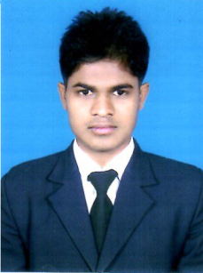
C/o-MOBILE: +97153718643
email: birendar.378014@2freemail.com

OBJECTIVE:

To contribute my best towards the attainment of organizational goals while enhancing my skills technically and functionally.

WORK SUMMARY

- Preparation mis-en-place of Buffet food of multi-cuisine & Al a Carte.
- Maintaining the standards &organising of work places.
- Supporting demi chef and chef-de partie
- Attending briefings and trainings about daily operation.

PROFESSIONAL SKILLS

- Time Management – Work under tremendous pressure & meet deadlines with ease and efficiency.
- Good Personal relations, communication and co-ordination.
- Ability to adapt easily to a new/changing environment.
- Knowledge in various cuisines (Indian,chineese,bakery)
- Computer Skills in Operating Word, Internet etc.

Academic Qualification
School | Exam | Year
High school bagodar (giridih) | JAC (Class X) | 2010
Markham collade of commerce | (Class XII) | 2013

Technical Qualification
School | Exam | Year
Institute of Hotel Management, | Diploma in hotel management | 2014 - 2015

Personal Details
Date of Birth : 01/01/1994
Marital Status : Single
Nationality : Indian
Religion : Hindu

Languages Known
(UK) English & Hindi with excellent fluency.

Work Experience :
Completed 6 months of Industrial Training, in Park Plaza hotel Bengalore (India)
Three months job training in hotel Park Plaza in BangaloreIndia
Eleven month work in Park Plaza hotel Bengalore

Extra Curricular Activities : Interest in playing cricket

Hobbies : Listening to music, sports and collecting
recipes from food shows.
Passport Details
Date of issue 04.04.2016
Date of Expiry : 03.04.2026
Place of Issue : Ranchi

Date
Place

