Curriculum Vitae
Present Address:

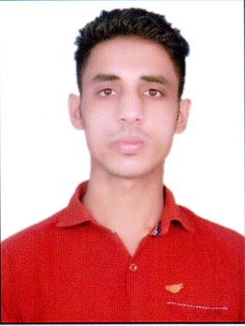
Sharukh
M.COM (ABST)
Deira dubai
Contract No. C/o 971504973598
E-mail Id – sharukh.378018@2freemail.com

CAREER OBJECTIVE

To work in a firm with a professional work driven environment where I can utilize and apply my knowledge, skills which would enable me as a fresh graduate to grow while fulfilling organizational goals.

BASIC ACADEMIC CREDENTIALS

Qualification | Board/University | Year | Percentage
M.COM | SHEKHAWATI UNI SIKAR | 2017 | 50.33
B.COM | Rajasthan UNI JAIPUR | 2015 | 55.38
12th | RBSE | 2012 | 72.00
10th | RBSE | 2010 | 66.00

COMPUTER KNOWLEDGE :-

COURSE | PERCENTAGE
RS- CIT | 82
CCC | PASS
TALLY | PASS

WORK EXPERINCE :-
ACCOUNTANT ( 1ST JULY 2015 - 1ST JULY 2017) at PADMAVATI MATERNITY & NURSIGN HOME.

Responsibilities:-
- Reconciled, investigated, and resolved discrepancies in monthly bank accounts.
- Assisted with month and journal entries.
- Collaborted with other deparments and staff to meet deadlines and achive goals.
- Prepared annual and quarterly reports.

CO-/EXTRA –CURRICULAR ACTIVITIE

- I participated In Many Cultural, Social Activities
- Experience of Various Coordinating Activities
- TALLY
- Knowledge of ms word and excel

ACHIEVEMENTS
- Actively participated in various sports activities for inter school.

INTERPERSONAL SKILL

  - Ability to rapidly build relationship and set up trust.
  - Confident and Determined
  - Ability to cope up with different situations.

AREA OF INTEREST

- Playing Cricket , Reading Books

PERSONAL DETAILS
- Date of Birth :- 14/06/1994
- Language Known :- English,Hindi & Urdu
- Strength :- Hard work , Smart Work, Zeal
- Interest & Hobbies :- Reading Book , playing cricket

DECLARATION

I do hereby declare that the above information is true to the best of my knowledge.

Place: Sikar Sharukh
Date:

