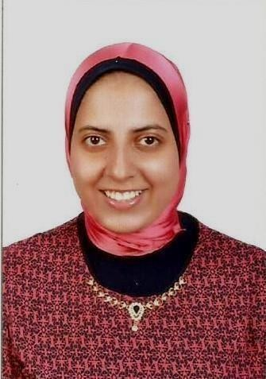

Esraa
C/o-Mobile Phone: +971501685421

E-mail: esraa.378035@2freemail.com

Date of birth: 7thNov 1992

Objectives:
Seeking to expand my experience as a pharmacist. Interested in a position where I can utilize my active experience and skills for delivering promising work. I like to build a strong foundation by learning every little concept about pharmacy while doing the task assigned to me. I would like to offer my expertise for performing in professional environment and to work with my full dedication, sincerity and hard work to learn more in this field of science.
CurrentDesignation: Pharmacist.

Nationality: Egyptian.

Age: 25 yearsold.

Familystatus: Married.

Qualifications: Bachelor of pharmacy (Alexandria University,Egypt).

Approved as a pharmacy pharmacist by DHA (DHA eligibility letter holder).

Years of relevant experience:4 years.

Visa status:Husband sponsor visa.

Work skills:
- Ability to learn fast and adapting myself to newtasks.
- Ability to work underpressure.
- Medication dispensing and a good knowledge ofmedicines.
- Communication and counselingcustomers.
- Good memory to memorize the upcomingmedications.
- Excellent interpersonal and presentationskills.
- Ability to lead, energetic, enthusiastic.
- Time management and ability to do multiple tasks, including customer service,technical and administrativetasks.

Language skills:
- Arabic: Mothertongue.
- English: Excellentcommand of written andspoken.
Courses:
- Microsoft office.
- BPS Preparation.
Work Experiences:
April 2017 to November 2017:
Out-Patient Pharmacist at Alexandria's Fever hospital.
Tasks:
- Prepares medications by reviewing and interpreting physician orders; detecting therapeutic incompatibilities.
- Supply prescribed and over-the-counter medicines to the general public and give advice to customers on the safe use of medicines and possible side effects.
- Preparation of pharmaceutical compositions according to physician’s prescription.
- Counsel patients: Counseling includes training patients how and when to take doses, sharing tips on how to minimize side effects while maximizing benefits and listening to all of a patient's concerns.
- Provides pharmacological information by answering questions and requests of health care professionals; counseling patients on drug therapies.
- Making sure needed products are stocked.
- Check the expiry date of the products in the pharmacy.
- Deals with all kinds of cosmetics products in the pharmacy.
December 2015 to March 2017:

Out-Patient Pharmacist at Ministry Of Health (At Health Unit).
June 2014 to June 2016:
Pharmacist at El Madina Pharmacy.

