CURRICULUM VITAE
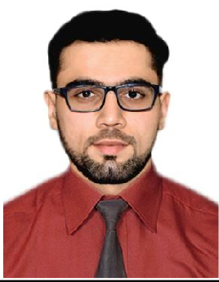
Name : Saakin
Email ID : saakin.378037@2freemail.com
C/o-Mobile No. : +971 505891826
Date of birth : 25th November 1996
Nationality : Indian
Marital Status : Single
Languages known: English and Hindi
Visa Status : Tourist visa

PROFILE SUMMARY
I completed my Bachelors Degree from Mumbai University with major in Marketing. Also have work experience in HR Department, Data Entry and Retail sector. I also possess basic computer skills along with knowledge of MS Office.

EDUCATIONAL QUALIFICATION

Examination | School/ College | Board/ University | Year of Passing | Percentage
T.Y.B.M.S.  (Bachelor of Management Studies) | K.P.B. Hinduja College of Commerce | Mumbai University | 2017 | 68.57
H.S.C | K.P.B. Hinduja College of Commerce | Mumbai University | 2014 | 75.54
S.S.C. | St. Mary’s High School | Maharashtra State Board | 2012 | 78.91

PROFESSIONAL EXPERIENCE
Bestseller (India): Fashion Consultant May 2017 to November 2017

- Contribute towards merchandising and keeping the ambience in accordance with the brand standards and guidelines.
- Good operation experience – receiving stock, cash handling, billing etc.
- Provide professional fashion advice to individual customers

Prime India Insurance Brokers (India): Account Executive October 2016 to January 2017 (as a part timer)

- Quality checking of proposal forms.
- Data entry in MIS.
- Dispatching documents and cards.
- Attending customer complaints.

Hamleys (India): Fun Consultant
April 2015 to August 2016 (as a part timer)

- Assisting customers and helping them to find the right product suitable as per their need.
- Visual merchandising.
- Ensure everyday targets are met.
- Contribute in achieving store KPI.
- Follow store policies and guidelines while converting potential customers to sales.

Soundlines Consultancy (India): Assistant HR March 2014 to May 2014 (3 months summer job)
- Assisting the HR in talent acquisition and recruitment processes.
- Provide support to employees in various HR related topics.
- Assist the clients in their travel requirements.

ADDITIONAL SKILLS
- Basic Computer Skills along with knowledge of MS-Office
- Ability to prioritize and handle multiple tasks in an organized professional manner.
- Willing to learn, accept new challenges and responsibilities.

