CURRICULUM VITAE

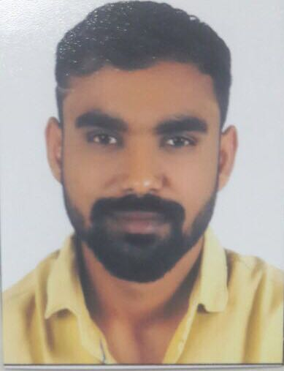

HITESH
C/o-Contact No. +971506425478
E-mail ID:- hitesh.378061@2freemail.com

Career Objective
To Work in a dynamic environment that provides me a vide spectrum of experience and exposure. To bring a dynamic and versatile portfolio of skills at work place and to serve the organization with positive attitude and efficiency.

Other Skill

- Good Team Work.
- Accuracy and Attention to details.
- Analytical thinking, planning.
- Problem analysis, use of judgment and ability to solve problems efficiently.
- Adaptability and ability to work under pressure.
- Time Punctuality & Regularity.
- Good domestic & international knowledge.
- Excellent interpersonal skills.
- Organizational skills.
- Energy.
- Resourcefulness.
- Confidence.
- Commercial awareness.

Professional Experience

Designation : Production Ass. Manager
Company : Prayas Engineering Company Pvt Ltd (Group of ELECON)
Company Profile : Manufacturer of Gear Boxes
Job Duration : 27th May 2007 to Jan 2012

- Planning of the entire ordered component on a weekly/monthly basis with parent company.
- Designing of Jigs & Fixtures & cutting Tools.
- Gear mfg. knowledge.
- Involvement for establishing quality system as per requirement of (ISO_9001).
- Working on ERP system (Oracle application) for WIP module.
- Shop floor planning and distribution of works to operators
- Process Inspection.
- Interaction with other teams / department for quality improvement.
- Maintain record of data related to Q.C. and Stores in ERP database

Designation : Corporate Sales Executive
Company : World Tel (Vodafone DSA)
Company Profile : Telecommunication
Job Duration : Feb. 2012 to July. 2012
Job Profile : Visits & Negotiations for Corporate Plans & Sales.

Designation : Store Supervisor
Company : Reliance Communications, RW Fatehgunj
Company Profile : Telecommunication
Job Duration : July. 2012 to May. 2013

- Retention & Churn Managment,pre2post Conversation,
- Revenue enhancement & store profitability,
- Latest process & products updates with the teams
- Maintaining Store Hygiene,I-sat,Involuntry Churn, Team Leading
- Responsible for maintain & report transaction database by cash, cheque & card payment as well as receipt of branch for retail & corporate clients

Designation : Store Manager
Company : Reliance Communications, (Dev Associates)
Company Profile : Telecommunication
Job Duration : Jun. 2013 to Dec. 2014

- Retention & Churn Managment,pre2post Conversation,
- Revenue enhancement & store profitability,
- Latest process & products updates with the teams
- Maintaining Store Hygiene,I-sat,Involuntry Churn, Team Leading
- Responsible for maintain & report transaction database by cash, cheque & card payment as well as receipt of branch for retail & corporate clients

Designation : Associates Manager (Baroda cluster cdma)
Company : Reliance Communications, RHRS ON ROLL
Company Profile : Telecommunication
Job Duration : Jan. 2015 to Jun. 2015

- Latest process & products updates with the teams
- Cdma Product sales

Designation : Store Manager
Company : Reliance Communications, (Krupa Associates)
Company Profile : Telecommunication
Job Duration : July. 2015 to Feb 2016

- Retention & Churn Managment,pre2post Conversation,
- Revenue enhancement & store profitability,
- Latest process & products updates with the teams
- Maintaining Store Hygiene,I-sat,Involuntry Churn, Team Leading
- Responsible for maintain & report transaction database by cash, cheque & card payment as well as receipt of branch for retail & corporate clients

Designation : Managing Director
Company : H R Immigration Visa Consultant
Company Profile : Packages & Visas.
Job Duration : March 2016 to January 2018.

- Domestic & international Packages.
- Book hotel reservations and direct customer package specifications.
- Respond to customer inquiries for general and package information.
- Student Visa for Singapore, Malaysia.
- Work Permit in Singapore, Malaysia, Thailend.
- Passport Application online.
- Visit Visa Application online.
- Tickets Booking Online.

Educational Qualification

- SSC from G.S.E.Board, Gandhinagar in March 2004

HSC from G.S.E.Board, Gandhinagar in March 2007

- B.sc. From Shri C.N.P.F Arts & D.N. Science College,Dabhoi in Jun 2010

Computer Skill

MS Office 2007, Windows 8, Windows Visa, Windows 10

Internet & Mail Assistance.
- Also have done CNC Programming 2007 IN KRINA TECHNICAL INSTIEUTE.

Personal Details

Birth date :- 12, Dec 1986
Nationality :- Indian
Languages Proficiency :- English, Hindi & Gujarati
Tourist Visa Valid :- April 27, 2018

