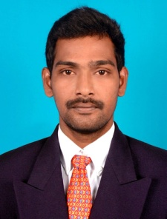
PAZHANI
C/o 971503718643
Pazhani.378064@2freemail.com

Objective:

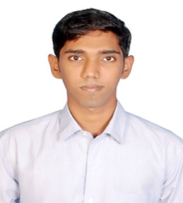
Seeking a position in an organization that provides me ample opportunity to explore & excel while carving out the niche for personal, professional as well as organizational goals.

Career History:

Company Name : KOCHAR Pvt Limited
Designation : Customer Service Associate
Duration : 26th july 2012 to 2013 september

Roles and responsibilities:

- Experience in customer support for Vodafone telecom industry.
- Providing support to corporate and retail customers in postpaid connection.
- Responsible for query, complaint and request from customer including follow-up and close looping.
- Making cold calls to customer for immediate resolution.
- Ability to work with minimum supervision in a busy environment.
- Providing full spectrum of service for customers who navigate both online or offline.
- Clarifying customer’s query in billing and network issue over email or phone.
- Achieving high standard customer’s satisfaction during adventuring into high performance.
- Faster reply to customer mails with minimum turnaround time.
- Supporting L2 in closing escalations in order to give resolution for customer.

Company Name : ALSTONE Limited
Designation : Sales Engineer
Duration : 15th December 2014 to 15th December 2015.

Roles and responsibilities:

- Market research and analysis.
- Experience in selling ACP Sheet products.
- Identifying potential dealers and demonstrating presentation about firm and its product.
- Prepare and deliver executive level presentations.
- Provide after-sales support to the dealers and end users.
- Supporting end user ACP Cladding.
- Identifying customer’s requirement.
- Conveying solution benefits to both business and technical audiences.
- Preparing reports for head office and senior managers.
- Maintaining existing, long-term relationships with customers.
- Strong time, project management and multi-tasking skills.
- Written and verbal communication skills.

Qualification:
Qualification | Institute/University | Place of Study | Year of Passing | Percentage
Msc(IT) | Annamalai University | Chidambaram, India. | Drop out | Nil
HSC | RCT Hr Sec School. | Chidambaram, India. | 2007 | 54%
SSLC | Govt Hr Sec School. | TN, India. | 2004 | 60%

Software Skill sets:

- MS Office
- MS Excel, C++

Personal Details:

Name : Pazhani
Date of Birth : 09th March 1989
Nationality : Indian
Marital Status : Single
Availability : Immediate
Language : English and Tamil

I hereby declare that all the information I have furnished is true to the best of my knowledge.

Place: Dubai (UAE) PAZHANI

