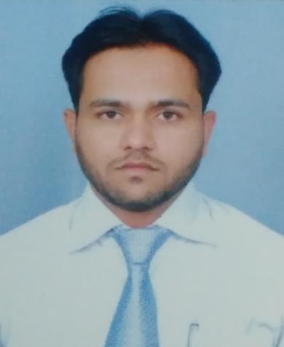Tahir
MBA (Marketing),B. Com

M+ C/o 971501685421
Tahir.378096@2freemail.com

OBJECTIVE

To effectively peruse my efficient marketing skills towards the furthering of my career and actively seek new opportunities to expand my horizons in other domains / specialties.

SHORT SYNOPSIS

A dynamic professional with over 4 and half years of extensive experience in Strategic planning, Sales & Relationship Management.

Presently working with MSN Laboratories

Pvt. Ltd. as Sales-Executive.

Adroit in handling relationship for running successful business operation & developing procedures.

Experience in Project analyzing.

Establishing healthy & prolonged business relation with clients.

Experience in conceptual marketing.

CORE COMPETENCIES

Excellent strategic sales techniques

Feasibility study and design & meeting sales goal

Strong client relationship management

PROFESSIONAL EXPERIENCE
MSN Laboratories Pvt.Ltd.- INDIA

Scientific Business Officer…..……………………….January 2016 – Continue

Role & Responsibilities

Meet up with the client.
Meet the sales target.
Market Up of the Company, by maintaining Relationship with
Stockiest and Clients.
Communicate with the client to meet up their needs.
Maintain relationship with the client, provide them after sales support.
Motivate the sub-ordinates to do business.
Handling and trained the new joiner.

Cadila Pharmaceuticals Pvt. Ltd. - INDIA

Sales Executive ….………………..….. August 2014 - December 2015

Role & Responsibilities

Creation of lead.
Meet up with the client.
Meet the sales target.
Maintain relationship with the client, provide them after sales support.
Maintain communication with the stockiest to meet the billing cycle.

Alkem Laboratories - INDIA

Business development Executive ……..………... June 2012 – July 2014

Role & Responsibilities

Working as a Marketing Executive in the Pharmacy Sales Industry.
Working in a group of 4-5 peoples to develop business for Area clients.
Responsible for communication with clients and Dealers and fulfill their product requirements.

Adept in handling all sales & marketing activities.

Deft in conceptualizing and implementing financial procedures actively.

An effective leader with excellent communication, analytical, team building
& relationship management skills.

SOFT SKILLS

• Leadership Quality & Management; based on topics like team building, process planning, Meeting management, Decision Making, organizing, controlling, coordinating, leading, troubleshooting, importance of leadership in an organization.

• Better Communication & Motivational

Skill to help the person to achieve targets
EDUCATION

B.Com University of Kota, Kota (Rajasthan - India) 2008

Senior Secondary Board of Secondary Education Rajasthan India 2005

Secondary Board of Secondary Education Rajasthan India 2003

PROFESSIONAL QUALIFICATION

MBA – Finance and Marketing 2009 - 2010
Rajasthan Technical University, Kota Rajasthan, India

PERSONAL INFORMATION

Date of Birth 11 November, 1986
Marital Status Married
Nationality Indian

