​Curriculum-Vitae
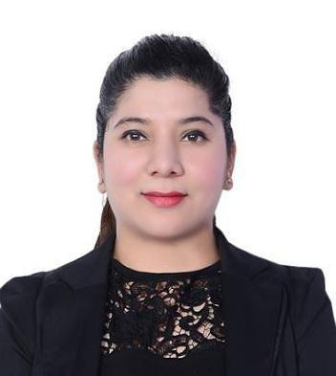

Neetu

C/o-Mob: +971501685421
Email: neetu.378111@2freemail.com
Dubai, UAE

Career Objective

To put forth my knowledge, talents & skills towards the advancement of the organization & also to work in challenging & creative environment by taking up the work assigned with great commitment and passion to the best of my ability.

Work Experience

Currently working in ​​Aster Medical Centre​(​Customer Care Executive​From 17th May, 2015)
Responsibilities:

- Serves as the core of communication within the work area. Assisting patients by greeting and helping them; scheduling appointments; maintaining records and accounts. Handles insurance and billing.

- Maintains patient accounts by obtaining, recording, and updating personal and financial information.

- Researched and solved claim and billing issues

- Handling the duty and responsibilities of Floor Supervisor

- Closing Tickets, duty scheduling, administration works,etc

- Maintained transaction report for client billing

- Interacting with clinical staff, patients, co-workers, and other departments in a positive and professional manner

- Deliver best-in-class customer service by fulfilling each customer’s unique needs while adhering to the policies

- Provide secretarial support such as answering telephones, assisting patients, making follow up appointments.

- Keeping front office area well organized and functional.

- Responsible for sending per-authorization request and insurance forms for approvals.

- Front office, billing & Office Administration.

V.P. Consultants
H.R. Recruiter Cum Coordinator​from (From 9th July, 2012 to12th August, 2014)

Responsibilities:
- Co​ordination for walk​in interviews closure
- Communication and follow –ups with candidate before and post interviews

- End to end coordination of interview till the candidate joins the Company

- Maintaining trackers for strong database ,daily report generations.

Educational qualification
- 10th​​Passed from C.B.S.E Board

- 12th Passed from C.B.S.E Board

- B.Com Pass from Manav Bharti University

- Pursuing PG in Hospital and Healthcare Management from Symbiosis

- Pursuing Certificate in Infection Control from Symbiosis

Skills Acquired

- Self motivation

- Customer service and orientation

- Team work

- Initiative and commitment to achieve

- Ability to adapt to any situation, willingness to learn and hard working

- Proficiency in communication skills

- Basic knowledge of computer (MS Office, Internet)

Personal Details

Date of Birth

Sex

Marital status

Language Known

Nationality

Visa Status

Notice Period

1st Feb 1987

Female

Single

Hindi and English

Indian

Residence

Hobbies

Watching Movies and Playing Table Tennis

I, Neetu Semwal, hereby certifying that all information stated above is true to the best of my knowledge.

