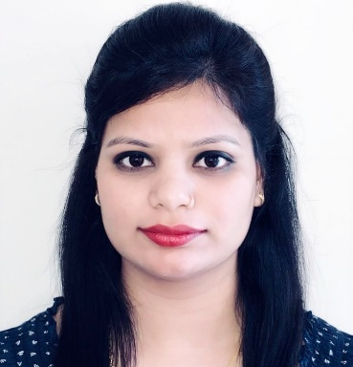
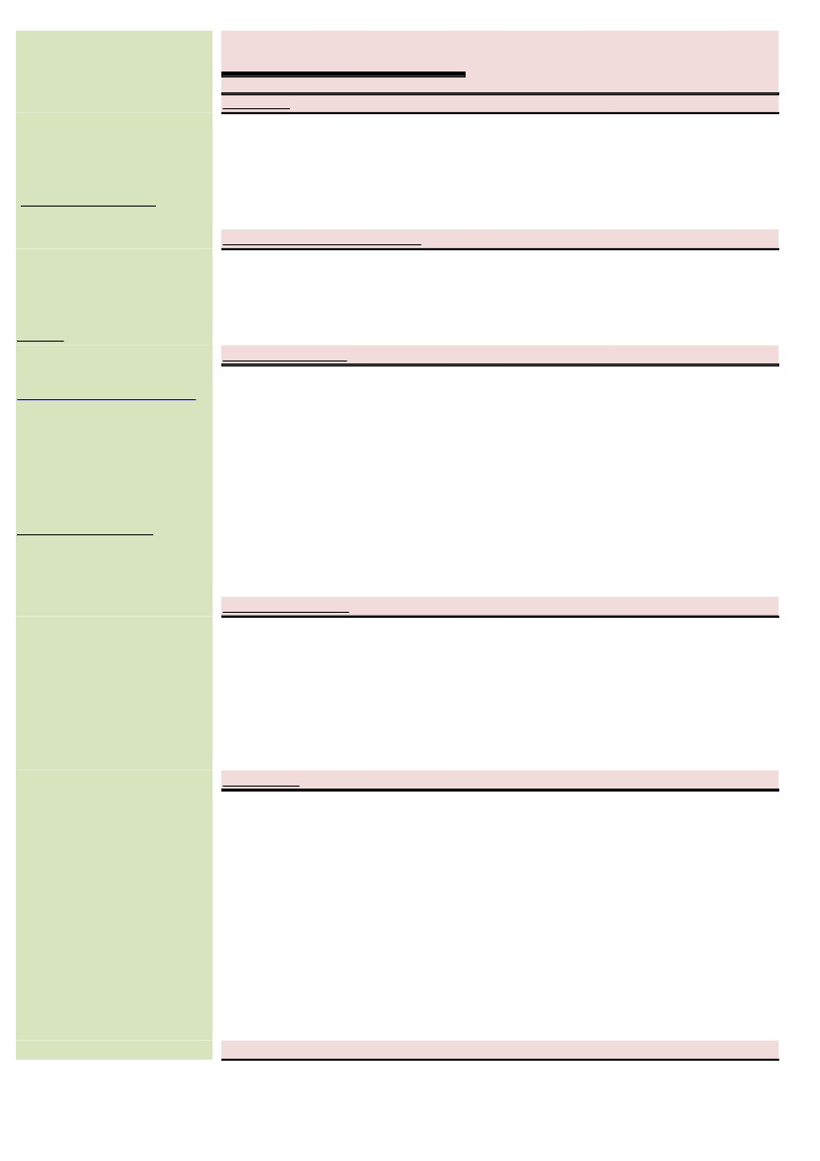
CURRICULUM- VITAE

OBJECTIVE

RAMA
Seeking a position to utilize my skills, ready to take challenges and be an asset to whichever company I belong and thrive to overwhelm the challenges with effortlessness and best potential clarification. To obtain a challenging position within a financial institution that will allow me to use my management, Sales & Customer service skills to help grow Company.

PROFESSIONAL QUALIFICATION

Contact Information:
Mob No.: C/o 971504973598

E-mail:-
Rama.378112@2freemail.com

Permanent Address:-

Dubai, U.A.E.
M.B.A

Post-Graduation

ACADEMIC RECORD
Board:

Board:

Graduation:

SOFTWARE KNOWN

Microsoft Office
Outlook Tally
Finacle

EXPERIENCE

- Reliance Communication.

- Kotak Mahindra Bank.

- IndusInd Bank Ltd
- Dr. C V Raman University (HR & Marketing)
- Value Institute (Post Graduate Program in Business Skills – PGPBS)

  - S.S.C (G.S.E.B)
  - Passed with 73.85 %
  - Year of Passing: Mar’10

  - H.S.C (G.H.S.E.B)
  - Passed with 62.38 %
  - Year of Passing: Mar’12

  - B.com (Sardar Patel University-Vidyanagar, GJ)
  - Passed with 64.04 %
  - Year of Passing Graduation: Apr’15

    - Worked as a Store in Charge For 09 Months from Jan’2016 to Sep’2016

*Worked as an Assistant Manager Sales from Oct’2016 to Jan’2017

    - Worked as an Associate Service Delivery Manager from Feb’2017 to Jan’2018

(...1...)

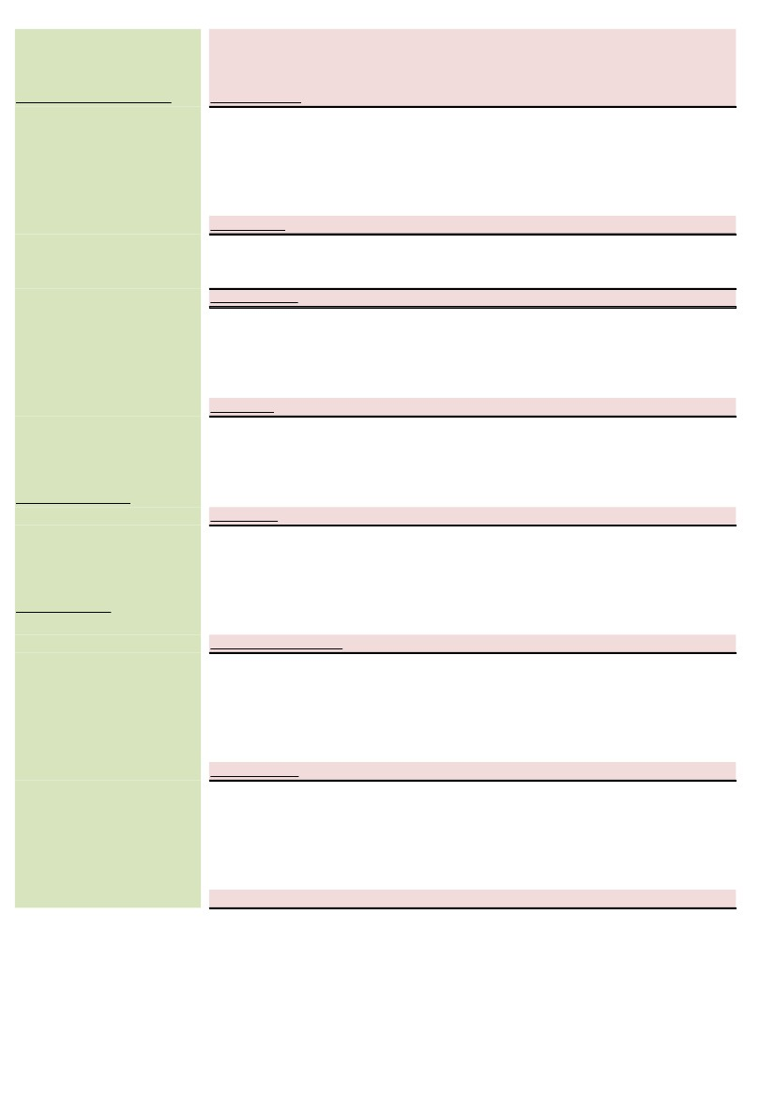

PERSONAL INFORMATION

Name:
Rama

WORK PROFILE

  - Complaints and Requests Handling
  - Client Engagements
  - Floor Managements
  - Audit and Monitoring
  - Daily Banking Related Operations

Date of Birth: 28.05.1994
Marital Status: Married Nationality: Indian

Languages Known:

  - English
  - Hindi
  - Gujarati

Visa Details:
On a Visit visa ending on
May 26th, 2018

JOB PROFILE

Associate Service Delivery Manager for Customer Services Department

ACHIEVEMENT

* Best customer services awarded for Q-1 and Q-2 (2016) In Reliance Communication.

STRENGTH

  - Hard Working * Good Team Player
* Accept Responsibilities * Active Listener
  - Positive Thinking * Quick Lerner

SOFTSKILLS

  - Ability to persuade people.
  - Flexible in Timing and have the ability to handle work pressure.
  - Accept all challenges given by the superiors and ensure to complete the task in given time.
  - Speaking confidently and being empathetic.

HOBBIES & INTERESTS

  - Photography
  - Travelling
  - Painting

DECLARATION

I hereby declare that all the information provided in this resume is true and Correct...

(. . End. . )

