Dear Sir/Mam

Your advertisement for a baker and cake decorator position on Web demonstrates that you are looking for someone with excellent cake artistic and the ability to meet the company’s targets in tight deadlines. As a proactive and mission oriented individual with 9+ years of cake baking and decorating with a solid understanding of modern business concepts, I am positive that I could meet and exceed your targets in timely fashion.

Having worked extensively as a cake artisan, I have had the opportunity to work closely with the senior managers to figure out sales strategies and work to achieve them.

Some of my areas of expertise lies include:
● Fondant Rolling
● Themed Baking
● Quantity Control
● Butter cream Consistency
● Packaging and Labeling
● Glazing and Icing
● Cake Decoration
● Baking Equipment Operation
● Recipe Development
Moreover, I possess exceptional presentation skills which would help me to communicate effectively with potential customers. With the ability to deal with multicultural population in local and international markets, I would be able to become an excellent representative of your team.

The enclosed resume speaks volumes about my ability to do this job efficiently. Because of my great passion, I’d like to meet with you in order to discuss this position thoroughly for which I’ll be expecting a call from your office to set-up an appointment. In the intervening time, I can be reached at (C/o 971503718643) or Email: evelyn.378155@2freemail.com

Thank you for your time and consideration.

Kind regards,

Evelyn

CURRICULUM VITAE

EVELYN IZUAGBE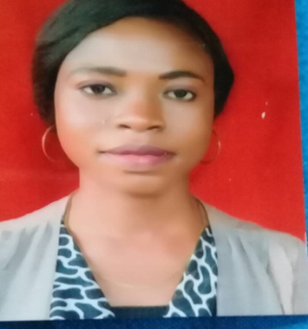

Tel: C/o 971503718643

Email: evelyn.378155@2freemail.com

PERSONAL DETAILS
Date of birth: 21-09-1988

Nationality: Nigeria

Sex: Female

Languages English, Youruba

Notice Period1 Month

Job Objective: To secure the position of baker and cake Decorator in a reputable company that will allow me to utilize acquired skills and experience.

Highlights
- Over nine years of baking and cakes decorating inlager and small events both formal and informal
- Substantial experience of decorating, piping and presenting cakes
- Extensive knowledge of bakery ingredients, cake decorating tools and food processors
- Commendable knowledge of food safety standards, sanitation policies, and health regulations
- Familiarity with applying icing, frostings, toppings, and fondants ability
- to read, comprehend, and follow recipes, correctly
- Ability to interact and work with all members of bakery team, in a positive manner
- Baking of cookies, pies, bread and pastries

Professional Experience:
Mix n Bake Confectionery & School 2010 – 2017
Head of Operations department
Responsibilities:
- Responded to customers’ query calls and took orders, in a prompt and professional manner
- Prepared, decorated, and packaged all varieties of cakes and cake products, efficiently.
- Proving training and seminars on baking and cake decorating techniques
- Priced, stored, and showcased all decorated cakes, as per department procedures and guidelines.
- Ensure cleaned, tidied, and organized all assigned sales counter and work areas.
- Completed and delivered all decorated cake orders to clients, on time.
- Developed and maintained cordial relationships with all coworkers and clients.
Major Accomplishments
• Organized workshops and seminars on cake decoration and various baking techniques
(Modeling, sugarcarft, royal icing, sugar paste and piping)
Exotique Cakes 2007 – 2010
Cake Decorator
Responsibilities:
- Assisted with preparation of cakes and executed all cake decoration activities, as assigned.
- Completed and submitted all cake production sheets, accurately and on time.
- Used and cleaned all culinary and decorating equipments, properly.
- Cleaned, sanitized, and organized all assigned kitchen areas and workstations.
- Interpreted and adhered to established health, sanitation, and safety standards and procedures.
- Developed and maintained strong professional relationships with team members, production staff, and other departments.
Education
- Bachelor of Science in Economics 2011 – 2015
Lagos State university
- Senior secondary school certificate 2006
- First school leaving certificate 2000
Technical Qualification
- Diploma in Sugar craft and cake decoration 2011
- Advance Diploma in Modeling and cake making 2013

