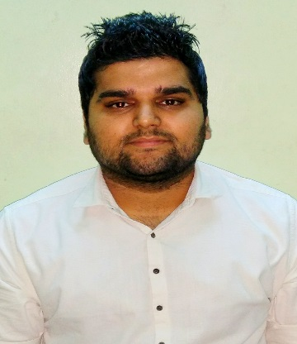

Abhay
E-mail: abhay.378157@2freemail.com
Mobile: C/o 971505891826

Objective:

Qualified Engineering professional with 2.9 years of experience in Business Development. Excellent written and communication skills. Highly skilled in identifying prospective group business, deciding group acceptance and maximizing revenue. A self-motivated and creative problem solver with the ability to build solid team relationships that produce strong and successful results. Reputed for exhibiting dynamic inductive reasoning problem sensitivity, strategic planning and effective leadership tactics.

Areas of excellence include:
- Client Relations
- Branding
- Employee training
- Lead generation
- Leadership techniques
- Revenue maximization
- Pricing Quotations
- Experience in Business Development.
- Responsible for Revenue Maximization.
- Experience in Business to Business and Corporate Sales.
- Proactive, foresighted, positive attitude and leadership skills with teamwork.
- Excellent communication & presentation skills.
- An outgoing personality with strong interpersonal skills.
PROFESSIONAL EXPERIENCE
Company | Zonixsoft (INDIA)
Profile | Business Development
Duration | 1st August 2014 to 25th July 2017

Role and responsibilities:
- Business Development
- Monitoring operations for planning and scheduling individual / team assignments to achieve goals within the time, quality and cost parameters.
- Formulating short term strategic plans to enhance operations, profitability & revenue targets.
- Formulating initiatives, planning and looking through execution for the marketing events for increased branding.
- Client Relationship Management
- Monitoring client interface in order to understand requirements and getting the job done as a team.
- Handling interaction with customers for effective resolution of grievances and obtaining feedback.
- Maximizing client satisfaction matrices by providing assistance and achieving delivery & quality norms.
- Confident negotiator and ability to ‘close the deal’.
- Strong client management skills and ability to keep promises.

Educational Qualification

JAMMU UNIVERSITY, INDIA: 2010-2014
MIET College, Jammu, J&K.
Bachelor in Engineering (INFORMATION TECHNOLOGY).

Interests
- Professional interests include High Potential Employees & Teams, Team Building, Strategy, Workforce Planning, and Corporate Social Responsibility.
- Personal interests include, Travel, Photography and Reading Editorial Articles.
- Fluent in English, Hindi.
- Visa: Visit Visa
EXTRA CURRICULAR ACTIVITI

