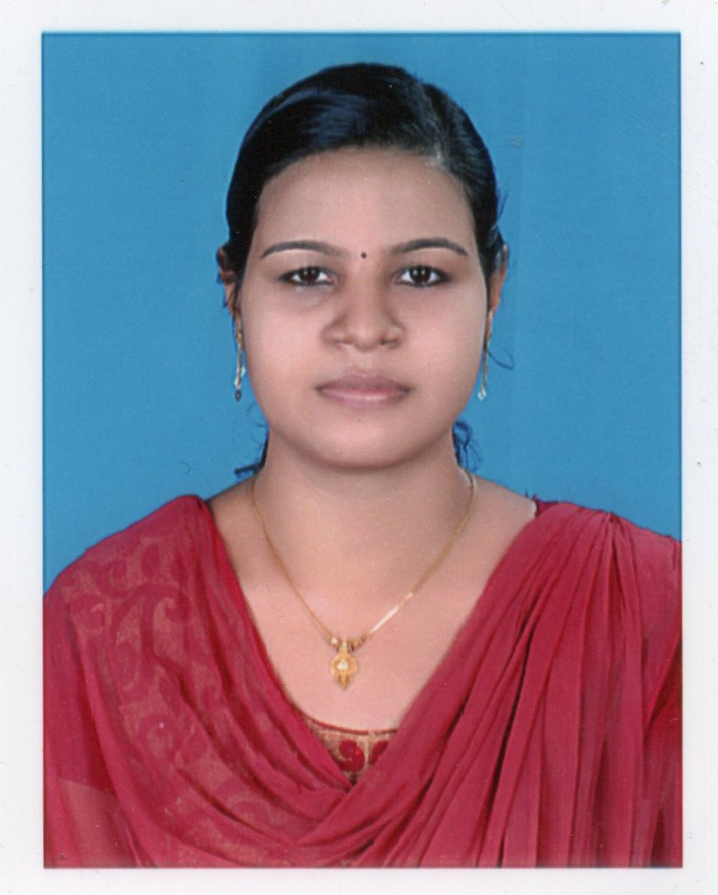
Contact Information  E-Mail:  Anjali.378178@2freemail.com  Contact No:+971504973598  Personal Profile:  Date of Birth : 05-12-1994  Sex : Female  Nationality : Indian  Religion : Hindu  Marital Status : Single  PASSPORT DETAILS  Place of Issue : Trivandrum  Date of Issue : 04/09/2015  Date of Expiry : 03/09/2025  Visa Status : Visit Visa  LANGUAGE KNOWN:  English, Malayalam &Hindi | ANJALI  Objectives  To accelerate my pace towards the growth of the organization by riding on my strength and to make innovations with my talented skills.  Academic Profile  POST GRADUATION:  Year of Completion : Doing  Course : M.Com  Specialization : Computer Application  UNIVERSITY : MADURAI KAMARAJ UNIVERSITY  VVM College, Kottarakkara, Kerala ,India (Distance Education)  GRADUATION:  Year of Completion : 2015  Course : B.Com  Specialization : Computer Application  UNIVERSITY : KERALA UNIVERSITY, TRIVANDRUM.  Classification : FIRST CLASS  ST.Cyril’s College, Kilivayal, Adoor , Kerala , India  HIGHER SECONDARY  Year of Completion : 2012  Course :PLUS TWO  Specialization :Commerce with Statistics  Board : STATE  Classification : Distinction  GOVT HSS Kulakkada , Kerala , India  MATRICULATION  Year of Completion : 2010  Board : STATE  Classification :Distinction  GOVT HSS Kulakkada , Kerala , India  Technical Skills  - DCA  - PDCFA (tally)

HOBBIES:  - Web browsing  - Social Networking  - Listening Music  - Gardening  KEY STRENGTHS  - Flexible to work in any environment.  - Fast & Self-directed learner, work effectively independently or as team player.  - Strong communication skills. | Projects  GRADUATION  - Main project – A study on Quality of work life of employees in IREL, Chavara.  DCA  - Main project – Hotel bill management system.  Experience  - Accounts Assistant in Muthoot Finance Pvt Ltd, Kottarakkara , Kollam Dist ,  Kerala , India.  1.3years (September 2016 to November 2017)  Job Description  - Working with spreadsheets, sales and purchase ledgers and journals.  - Preparing Statutory Accounts.  - Calculating and checking to make sure payments , amounts, and records are correct.  - Reconciling finance accounts and direct debt.  - Sorting out incoming and outgoing daily post .  - Managing petty cash transaction  - To complete and coordinate annual audits and provide recommendations for improving procedures and systems for initiating corrective actions.  - Check all financial transaction for accuracy.  - Track expenses as they relate to specific projects and jobs.  - Assisting Accounts Manager with audits , forecasts and  Other fiscal planning.  - Customer care executive in  Oyster Communications Vodafone mini store ,  Enathu , Pathanamthitta Dist ,Kerala , India.  1.2 years ( July t2015 to August 2016)  Job Description  - Answer calls professionally to provide information about products and services, take/ cancel orders, or obtain details of complaints.  - Keep records of customer interactions and transactions, recording details of inquiries, complaints, and comments, as well as actions taken. Process orders, forms and applications  - Refer unresolved customer grievances or special requests to designated departments for further investigation  - Follow up to ensure that appropriate actions were taken on customer’s requests.  - Computer Teaching Faculty in CAIT ,  Enathu , Pathanamthitta Dist . Kerala India.  1.3 years ( April 2015 to June 2016 )  Job Description  - Create lesson planes that are appropriate for the age and abilities of students in the class.  - Encourages creativity of students.  - Making theory classes and practical class of  MS Excel , MS Word , MS Powerpoint , C++, Java,  .Net. and VB  - Runs the classroom within the allocated budge  Reference  Submit as on request.  Declaration  I hereby declare that all the information mentioned above is true to the best of my knowledge.  Dubai ANJALI .

