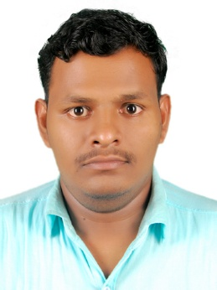
KABIL
E-mail: kabil.378182@2freemail.com
Mobile: +971502360357

-------------------------------------------------------------------------------------------------------
Web Developer
-------------------------------------------------------------------------------------------------------
To be in a organization where I can contribute my skills and knowledge effectively.

Academic Qualification:

- Vocational Higher Secondary School:
K.K.M.G.V.H.S.S Vadakara( Kerala State Board)
- Engineering Graduation in Computer Science:
Ganamani Collage of Technology(Anna University Chennai)

Experience Profile:
- AIN TECHNOLOGIES
Kerala, India.
Position: Dot Net Developer
Duration: From 13thMay 2013 to 12th July 2014

- FASTGEN TECHNOLOGIES
Kozhikode ,India.
Position:PHP Developer
Duration:From 8th January 2015 to 8th February 2017
Skill Set :

- Internet Technology :-Html,Php,JavaScript,JQuery,Css,Xml,Bootstrap,Asp.net
- Frame Work :-Mvc
- E-Commerce :-Open Cart,CommerceSEO,Wordpress
- Database :-Sql Server2005
- Ide :-Visual Studio 2008,Dreamweaver,Microsoft Office,PowerPoint,Photoshop
- Operating System :-Windows 7,Linux

Area of interest:

- Coding
- Web Design
- IT Support
- Document Controller
Professional traits :

- Self-Motivated &Self Starter.
- Dedicated mind for committed work.
- Hard Work.

VERIFIED PERSONALLY,
Truly,
Kabil. K,
Deira, UAE.

