Curriculum Vitae

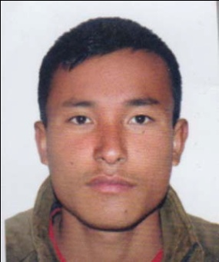
BIJAYA
Mob:C/o 971503718643 (UAE)
Dubai-UAE

Post applied for :Any Suitable Jobs

Objectves

Looking for the opportunity to work with your progressive organization that gives me scope to update my knowledge and skills in accordance with the attest trends and be a part of them that dynamically works towards the growth of organization and gain satisfaction thereof.

Personal skills

- Good team player, Communicate with accuracy and tact.
- Punctuality and honorable, Responsible and enjoy to have responsibilities.
- Quick understandings and fast proceed, Good maintenance skills.
- Highly adaptive to fast changing technologies, Easily mingle with people.

Personal Information
Name :: BIJAYA
Date of Birth :: 15/12/1995
Nationality :: Nepali
Gender :: Male
Marital Status :: Married
Visa status :: Employment Visa

Academic Education
Academic :: S.L.C,+ 2
Computer Knowledge :: Basic Knowledge Like MS Word,Excell and Internet
Languages:
English, Nepali, Hindi
Experience Summary :
- Presently working as General Assistant F &B Airport Production in Emirates Flight Catering Dubai Airport-Dubai- UAE.
- Worked as a Waiter in Dwarika Hotel in Nepal for 3 years.

Passport Details
- Issued Place :: Kathmandu
- Issued Date :: 16 March 2015
- Expiry Date :: 15 March 2025

Declaration
Here I am kindly declared that the above mentioned details all are true in the best of my knowledge and believe.

