TINTO
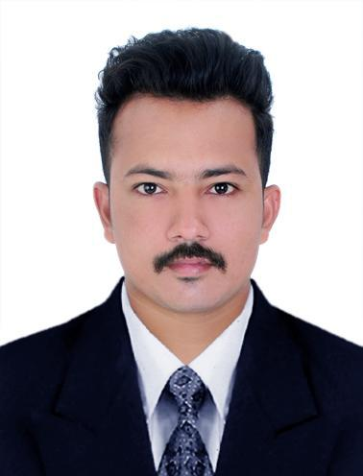

C/o- : +971-501685421

Tinto.378217@2freemail.com

Objective

An enthusiastic employee with highly motivated to work in any drastic situations in an organization to improve my skills and knowledge along with the organizational goals.

Summary

• | Profile: | Male,25,Single
• | Nationality: | Indian
• | Current Location: | Sharjah,UAE
• | Visa status: | Visit/Tourist
• | Current Position: | Site Engineer
• | Company: | Pellica Marine
• | Preferred Location : | UAE
• | Salary Expectation : | Negotiable

Work Experience

Jun 2017- Feb 2018 Pellica Marine Kerala,India

Site Engineer

Worked as a site Engineer at Pellica marine for air pressure testing and leakage identification in ship clusters.

Education

Jul 2014-Feb 2017 MG University Kerala,India

Bachelor’s Degree in Instrumentation and Control Engineering CGPA:6.74 (First Class)

Aug 2011-May 2014 Kerala State Technical university Kerala,India

Diploma in Electronics and Instrumentation

CGPA : 6.34 (Second Class)

Skills

Language
• | IELTS | Expert
Windows & Office tools
• | MS Word | Expert
• | MS Excel | Expert
Programming & Development
• | Picosoft | Expert
• | Logixpro | Expert
• | Matlab | Expert

Languages

• | English | Native
• | Hindi | Proficient
• | Tamil | Average
• | Malayalam | Native

