SHINOJ 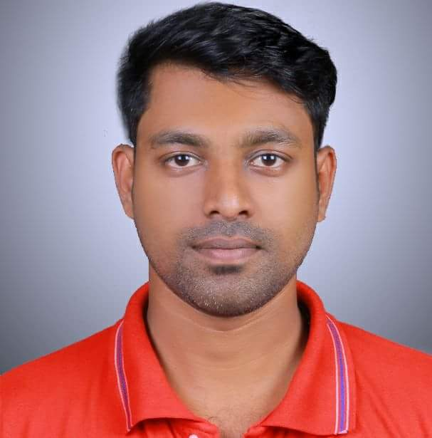
Ras Al khaimah
Cell: C/o 971505891826
E mail ID: shinoj.378223@2freemail.com

CAREER OBJECTIVES
- To gain the position of store operations in charge wherein my customer service skills and people management skills will make a notable contribution towards the growth of the organization and personal growth.

PROFESSIONAL STRENGTHS
- Excellent communication and interpersonal skills
- Excellent time management and organizational skills
- Persuasive, emphatic with good problem solving skills
- Good knowledge of Microsoft Outlook, excel and Internet Explorer
- Ability to deal with external and internal customer support in a professional manner
- Quick learner, detail oriented and ability to adapt to new processes in limited time frame
- Multi-tasking skills and ability to work under pressure

EDUCATIONAL QUALIFICATIONS

- VHSC (Completed)
- B-COM (Pursuing)

PROFESSIONAL EXPERIENCE

Organization: Ethos Entertainment,
Duration: APRIL 2013 till DECEMBER 2017
Designation: Area Sales Manager
- Establishes dealer networks, creates and manages alliance with sales channels
- Appointing new dealers for increasing sales
- Ensures that all the request, queries and complaint of customer are responded in a timely and professional manner
- Develops as well as maintains the relationship with external parties
- Responsible for proper scrutiny and recording of the complaints/ suggestions received from customers
- Conducts research and complies answers for informational request from external customers.

Organization: Music World Retail Ltd,
Duration: MARCH 2009 to MARCH 2013
Designation: Supervisor and store in charge

- Serves as a basic point of contact for customers with requests, complaints, queries, feedbacks etc.
- Prepares daily reports on the daily activities of Customer Care team.
- Ensures that all the request, queries and complaint of customer are responded in a timely and professional manner.
- Develops as well as maintains the relationship with external parties.
- Responsible for proper scrutiny and recording of the complaints/ suggestions received from customers.
- Conducts research and complies answers for informational request from external customers.
- Daily briefing to front end sales staffs. Distributes the targets and ensures the achievement.
- Cash deposit, store housekeeping, inventory control procedures, recruitments, training, and welfare activities.

Organization: WORLDSPACE, Cochin
Duration: JANUARY 2005 to FEBRUARY 2009
Designation: Sales Executive

- Responsible for sales and service of satellite radios. Also enthusiastically present them the range of radio channels at the World Space.
- Coordinates with Technical support team and Departments in handling issues.
- Provides customer support and handles the queries of clients.
- Make soft calls and fix appointments in coordination of sales and marketing team for prospective customer.
- Follow-up and track on customer enquiries.
- Maintains record of all enquiries & related details in Computer Systems.
- Provides all Back-office support tasks like sending and receiving mails.

AREAS OF INTEREST
- To exceed the expectations of the organization and achieve customer satisfaction.
- To contribute my customer service skills in solving complex customer problems.
- People management.
- Store marketing.
- Visual merchandising.

PERSONAL DETAILS

- Age & DOB : 31, 23-04-1986
- Marital Status : Unmarried
- Gender : Male
- Languages Known : Malayalam, Hindi and English
- Nationality : Indian

DECLARATION

I am keen to continue my career and prepared to work hard in order to achieve my organisation objectives and I hereby declare that the information furnished above is true to the best of my knowledge.

Place: Ras Al khaimah
Date: 28th Feb 2018

(SHINOJ)

