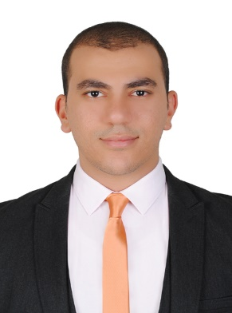  Dubai Marina  United Arab Emirates |  |  | C/o 971501685421  Shady.378251@2freemail.com  Shady  Medical Representative
About me

Talented Medical Representative effective at building loyalty and long-term relationships with customers while exceeding sales targets.
Languages

Arabic: Native
English: Fluent (Speaking, Reading and writing)

Education

Bachelor Degree
Future University in Egypt - Class 2014
Pharmaceutical Sciences and Industries

 |  | Skills  Sales analysis  Negotiator  Extremely organized  Strong verbal commuication | Resource planning  Market trend analysis  Territory management  Proficiency with CRM systems

 |  | Certifications  Novartis Customer Solution Model  Present to impress | Performance frontier (Novartis sales course)  Arrow and time sensitive sales calls

Experience

Novartis Pharma Egypt
line: Hypertension 2 (HTN2) Cardiometabolic franchise

From May 2016 to June 2017

Responsibilities:
- Promote products to physicians and HCP by executing effective and productive sales calls.
- Manage military hospital accounts.
- Arrange meetings, events and round table discussions with HCP to build rapport and get insights.
- Collaborate with manager to develop and implement a territory and account plan.
- Deliver presentations for product promotion and Disease awareness in group meetings.
- Engage with peers and managers to learn best practices.
- Create accurate reports of visits and customer activites on CRM systems and keep data up to date.
- Identify and gather competitive information to obtain an edge over competition.
- Learn and actively participate in training programs assigned by company.
- Comply with company’s Business practices code, code of conduct internally and externally with customers and associates to maintain a culture of respect, diversity and productivity in the workplace.

Personal info

Name: Shady
Date of birth: 3/5/1991
Driving License:Available

