CURRICULUM VITAE
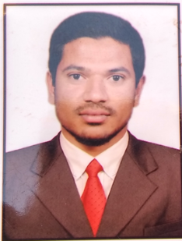

Nizam
Email Id:
Nizam.378262@2freemail.com
Contact Number:
C/o 971504973598

Personal Profile:
Gender: Male
D.O.B :30-07-1993
Marital Status : Single
Expiry Date :16-07-2025
Linguistic Proficiency
English
Hindi
Urdu
Kannada

Visa Status:Visiting Visa
Visa Validity: 29-05-2018

Career Objective:
Seeking a position to utilize my abilities and skills in the Industries that professional growth while being resourceful, flexible and innovative. To work in a competitive world by making the best use of my skills and capabilities.
Career Summary:
- Invoice processing in accordance with the requirement of Service Level Agreement agreed by clients.
- Processing the invoices for European countries like UK, Italy ,Portugal,Germany and Poland etc.
- Processing of normal, and critical payments like urgent Payments promptly, accurately and efficiently.
- Assisted lead cashier in execution of merchandizing and billing operations.
- Processed merchandise and ensured stock availability on the assigned floor.
• Guided customers and provided them with highest quality of customer service
• Ensured loss prevention procedures.
• Stocked merchandise in check stand area.
- Day to day preparation of reports and sending it to the concern department.
- Make use of oracle and tally applications for bill postings.
Work Experience:
Assigned Role:
COMPANY | DESIGNATION | EXPERIENCE | Year | LOCATION
Vodafone south india ltd | Cashier cum accountant | 13 months | 2015-2016 | Bangalore, India
Hewlett packard | Financial associate | 12 months | 2017-2018 | Bangalore, India
•Work with multiple tools like – SAP, Oracle, Tally ERP.9.

Roles & Responsibilities:

- Appreciated by management for Hard Work and Dedication Supporting the team.
- Making reversals and corrections for invoices posted incorrectly.
- Make use of SAP accounting software for proceesing the payments .
- Processing of PO (MM) and Non-PO (FI) invoices.
- Verification of critical payments and high value payments which are more than 10K and 100k invoices.
Qualification:
•B COM from Bangalore University with 74%
•2nd P.U.C in 2012 from KEB 86.33%
•10th in 2010 from KSEEB with 50%

Declaration:
I undersigned hereby declare that the information given above is true to the best of my knowledge, information and belief. I also assure you that if given an opportunity to join in your esteem organization. I will discharge my duty with sincerity and honesty to the satisfaction of my superiors.

NIZAM

