CURRICULUM VITAE
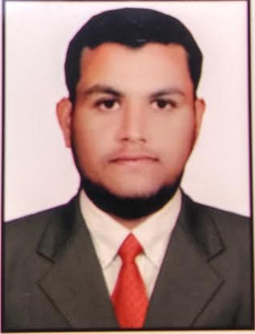

KHALEEF
Email Id:
Khaleef.378263@2freemail.com
Contact Number:
C/o 971504973598

Personal Profile:
Gender: Male
D.O.B : 22-04-1993
Marital Status : Single
Expiry Date :30-06-2025
Linguistic Proficiency
English
Hindi
Urdu
Kannada

Visa Status:Visiting Visa
Visa Validity: 29-MAY-2018

Career Objective:
Seeking an opportunity to work in challenging environment, learn new skills and enhance the same for company’s growth and development, to apply my academic knowledge for achieving organizational goal as well as my personal enrichment.
Career Summary:
•Verification of supplier invoice copy.
•Setting up supplier bank details and address detailsfor the invoice payment with different payment method.
•calling to the supplier in different regions.
•End to End update (from vendors till support).
•Listening to vendor’s requirements and creatingaccordingly for payment request.
•Maintain records and report the accounting enquiries,

Work Experience:
Assigned Role:
•Worked in IBM INDIA PVT LTD as Practitioner in Finance and Accounts from 2015 to 2016.
•Worked in NORTHERN TRUST asAccounts payable Analyst
From years 2017 to 2018 February
•Work with multiple tools like SAP, TALLY ERP 9.0, ORACLE.

Roles & Responsibilities:
Have an experience in Accounts payable such as
- Indexing, invoice processing, Manual invoices posting, direct debit reporting, tax posting, query mail handling and urgent payment requests.
- Creation of suppliers for all the regions EMEA, APAC, North America like, US, UK, MIDDLE EAST, CHINA JAPAN, HONGKONG, PHILLIPINES, SINGAPORE AND INDIA SUPPLIERS.
- Creation of suppliers and Reactivation and Deactivation of vendors like, Charity supplier, Intercompany suppliers, Association’s, legal settlements, Government suppliers, and Utility suppliers, Sponsorships suppliers.
- Contacting suppliers through telephonic mode and emails for required information to set up the suppliers for all the regions,
- Additional activities: DENIED VOCHERS, EPR, ERM, EDM, Daily- ALLOCATIONS, and CLOSING STATUS OF ALLOCATION.
.
Qualification:
•B COM from Bangalore University with 70%
•2nd P.U.C in 2012 from KEB 85%
•10th in 2010 from KSEEB with 50%

Declaration:
I undersigned hereby declare that the information given above is true to the best of my knowledge, information and belief. I also assure you that if given an opportunity to join in your esteem organization. I will discharge my duty with sincerity and honesty to the satisfaction of my superiors.

KHALEEF

