Nada
Medical Representative

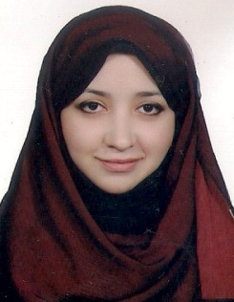

Personal Data
Name:Nada
E-mail: nada.378268@2freemail.com
Contact : C/o 971501685421
Marital status: Single

Education

- Ahlia High School - Kuwait /2005
- University :German University in Cairo -July 2010
- Post graduate studies :
Clinical Pharmacotherapy (Phoenix university-Canada)
Clinical Nutrition (Ain Shams University – Egypt)
Training courses
- Green pharmacy course-Egypt /2008
- Third student conference on Pharmaceutical Studies (SCOPS) –Egypt/2008
- Board of Neuro-Linguistic programming –Egypt/ 2010
- Pfizer leader development group–Egypt/ 2010
- Novartis Market Research–Egypt/ 2010
- Member of Egyptian Pharmacist Syndicate - 2010
- Community pharmacy course –Egypt/2010
- IELTS 7 –British Council-Kuwait/ 2012
- Presentation skills (Global consultant Institute)– 2014
- Presentation skills (Galderma)-Dubai 2016

Working experience
- Synergy – Medical Representative
Dec 2017-now
Job description
Introducing new products into main accounts
Achieving sales target

- Galderma International - Medical Representative
Jan 2016-July 2016
Job description
Achieving sales target
Getting regular feedback on latest market concerns
Achieving call objectives

- DOWA – Medical representative/Business & Development
Jan 2014-Nov. 2015

- Alia International Hospital-Pharmacist
Feb 2011 – Dec.2013
Job Description
Patient counseling
Handling and dispensing prescriptions
Experienced at Oracle retail merchandising system

