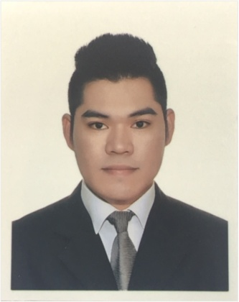
ANJAKE
Al Rigga Dubai, UAE Email Address: jhake.378272@freemail.com Contact Number: C/o 971503718643
Summary
Consistently recognized for leadership and high service levels toward business success; works independently, responsible, driven by high standards and focus on career objective. Been four years in restaurant business and was able to deal with different kinds of situations. Knowledgeable in office works, sending reports, inventory, excellent in customer service and smart working.
Experience
800 Degrees Neapolitan Pizzeria (Supervisor) 2015-2017
- Implementing restaurant food code and policies to make sure all standards must be followed.
- Supervised restaurant operation, promoting brand and achieve targets.
- Sending office reports, dsr, inventory and attend management meetings.
- Maintaining a great feedback from guest and deliver high quality of service beyond expectation.
Johnny Rockets Hamburger / 2013-2015
- To deliver friendly, efficient guest service and to create a warm and welcoming atmosphere for all of our guests, with the key aim of retaining and attracting new customers.
- We served the freshest, highest quality simple all American fare.
- Promote our Hamburgers as one of the “Best Hamburgers in Town”.

Educational Attainment
Bachelor of Science in Hospitality Industrial Management and Tourism / 2008-2012 International School of Asia and the Pacific, Philippines
Certificates
PIC (Person-in-Charge) Valid from 2016-2021 TSI Quality Services Person-in-Charge Level 3, Dubai UAE
Best Employee of the Month / 2014-2015 Johnny Rockets Hamburger, Abu Dhabi, Dubai

