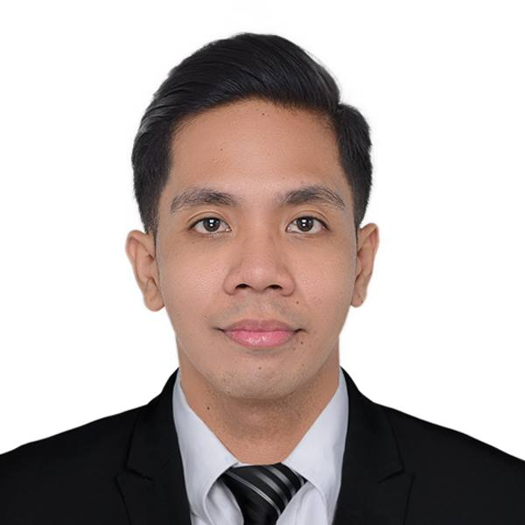
Engr. Jaydolf
Deira, Dubai, UAE
Contact number: C/o 971501685421
E-mail Address: jaydolf.378276@2freemail.com

SUMMARY OF QUALIFICATIONS

- Registered Electrical Engineer
- 4 years of experience in Engineering and Construction
- 1 year of experience in Hotel/ Hospitality Industry
- In-depth knowledge of Electrical system designing, testing and commissioning, estimation and costing, maintenance
- Office administration skills, including team management and inventory management skills
- Competent with most Microsoft Office programs
- Fundamental knowledge of AutoCAD
- Ability to determine work priorities
- Ability to communicate with others, both verbally and in writing
- Ability to supervise and ensure a safe working environment

PROFESSIONAL EXPERIENCE

ElectricalSupervisor January 2017 – January 2018 The Peninsula Manila Hotel
Corner of Ayala and Makati Avenues, 1226,
Makati, Metro Manila, Philippines

- Plan and schedule projects, estimate time and materials and prepare reports
- Plan and supervise the work of electricians
- Plan and estimate electrical jobs
- Maintain records of electrical jobs and assign to appropriate personnel
- Assist in coordinating job assignments with the other trades, e.g., plumbers, carpenters, etc.
- Assist contractors on jobs
- Advice coordinator and assistant director of technical problems concerned with installation, modification, and repair of electrical assignments
- Recommend procedure revisions when necessary to fully utilize assigned personnel and equipment
- Determine procedures for maintenance, installation, modification, and repair of electrical assignments
- Inspect work to ensure compliance with standard procedures and electrical assignments
- Examine electrical services for proper working procedures
- Perform other Engineering related duties/activities as required by the Operational Manager

Electrical Engineer II November 2012 – January 2017
Taikisha Philippines Inc.
Golden Rock Bldg, 168 Salcedo, Legazpi Village,
Makati, Metro Manila, Philippines

Responsible for providing assistance to the Project Manager/Project-in-charge in the implementation of approved design, specifications and materials and its proper maintenance during the warranty period until its full turnover to the client.
- Design and calculation of electrical and electronics system
- Regularly inspects work of subcontractors to see to it that the approved designs, specifications and materials are followed and implemented
- Conduct daily toolbox meeting and inform daily activities and safety concern
- Regularly checks the number of manpower supplied by the subcontractor to monitor target completion date of a specific phase of the project
- Provides the Project Manager/Engineer-in-charge the status report of the project
- Prepares weekly/daily project schedule of activities for the guidance of the Project Manager/Engineer-in-charge
- Estimate and take-off all the materials needed for the project
- Prepare quotation for the scope of works
- Checking of the materials & equipment to be used prior to Client and project requirements
- Coordinates with Purchasing Department regarding purchase and delivery of materials and equipment needed for the project
- Monitors and controls materials delivered/allocated for the project
- Attends meeting with the general contractor and subcontractor for the coordination of the following:
  - schedule of activities
  - manpower requirement
  - material requirement
  - problems in the project
- Attends to additional works requested by the client/owner by:
  - conducting a study of additional requirements by the client/owner
  - preparing report and recommendation to Project Manager/Engineer-in-charge regarding additional requirements of the client/owner
- Renders inspection, testing, and operation of mechanical, electrical systems
- Prepares Preventive Maintenance Manual for client’s use
- Supervises installation of electrical and electronics systems (i.e. panel boards, lighting, small power, FDAS, CCTV) in accordance with specification standards until it is completely in good running condition and ready for startup
- Prepare proper execution plan as per project quality and safety requirement
- Train newly hired subordinate employees as well as agency personnel on their respective job duties and responsibilities
- Performs duties as an official Safety Officer
- Performs other tasks that may be assigned/required by superior from time to time

Internship April 2011 – May 2011
National Grid Corporation of the Philippines
Emilio Aguinaldo Highway Dasmariñas, Cavite,
Philippines

- Regularly monitor power transformer and current transformer
- AutoCAD operator

Internship June 2008 – August 2008
Liwayway Marketing Corporation (OISHI)
CBI Complex, Km. 23 Aguinaldo Highway, Anabu 1-D,
Imus, Cavite, Philippines

- Receive and scan delivered items and ensure quality
- Sort, organize and store inventory in the proper location
- Prepare documentation and inventory for audits
- Perform minor electrical maintenance
- Receives direction, guidance, and instruction from building maintenance Technicians and supervisor in the correct operation of equipment and materials used to complete the required maintenance activities.

TRAINING AND SEMINARS ATTENDED

- First Aid and Basic Life Support Training
Red Cross
Bel Air Subdivision, Sta. Rosa, Laguna
(August 24-25, 2016)

- Fire Protection and Prevention
Taikisha Philippines Inc,
Filsyn Compound, Sta. Rosa, Laguna
(August 23, 2014)
- Job Hazard Analysis Training & Workshop
Taikisha Philippines Inc.
Sta. Rosa, Laguna
(September 04, 2014)

- Emergency First Response Training
First Philippines Industrial Park
Sto. Tomas, Tanauan, Batangas
(August 21, 2014)

PERSONAL INFORMATION

Date of Birth : February 9, 1990
Gender : Male
Marital Status : Single
Nationality : Filipino
Visa Status : Visit
Language Skills : English, Filipino

EDUCATIONAL ATTAINMENT

Registered Electrical Engineer
Reg. Date: Oct. 5, 2012

Bachelor of Science in Electrical Engineering
Technological University of the Philippines Manila Campus
2006-2012

I hereby certify that the above information is true and correct to the best of my knowledge and belief.

