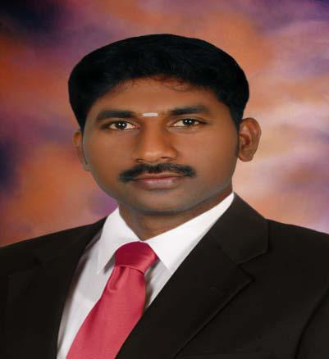
Resume

EZHUMALAI

C/o-Mobile no (UAE): +971501685421

E-Mail: mzhumalai.378297@2freemail.com

Objective

Intend to build a career with leading corporate of hi-tech environment with committed & dedicated people, which will help me to explore myself fully and realize my potential. Willing to work as a key player in challenging & creative environment.

Technical Qualification

- Completed Diploma in Mechanical Engineering (82% Marks) - (2001 to 2003)

- C.N.C Lathe and Milling programming & operation in VMX Training center, Aranthanki

- AUTO CAD Training course in CSC Computer center in pondiche

- Creo 3D designing course undergoing

Educational Qualification

- SSLC passed certificate from government of Pudhucherry

- HSC passed certificate from government of Pudhucherry

Employment History

1. Company : EMIRATES TECHNO CASTING FZC(Hamriyah free zone, Shj)

: Now changed name to Pentair Gulf Valve

Designation

: Production Supervisor

: VTL, HTC, HMC &Turn Mill-Machine Programmer

- Chuck Dia 200 mm to 3000mm

- 5Axis Valve Machine (sinumeric 840d )

- Ball grinding machine( 840D-turning and grinding possible for 6”to 36”)

- Turn mill-( Fanuc control )

Period : Since April 2005 –To-Sep 2015

Company Profile:-

Pantair :. is one of the main MNC companies in the production and exports of Valves steel casting, Ball valve, check valve, Gate valve, Butterfly valves & Oil field materials. The company exports its products to foreign companies in USA, all Europeans country also. The products of the company customer are Shell,Emerson,JC Valves,Tyco Valves, The company is an ISO organized one.

Role & Responsibilities:-

Supervisor:

- As per Planning, start the Production

- Daily Production Monitoring

  - Explain & Training to operator about of Safety & Quality

  - Take time study of Production job

  - Maintain the Rout sheet& Job card

  - Follow the Attendance& Arrange weekly shift schedule

  - Prove the first Piece

  - Maintain production report

  - Improve the quality of the job

  - Improve output

  - Good communicate with management & workers

  - Check Dimension Report which is supplying to QC.

  - Maintenance of machines.

  - Guide Operators and setter to have a efficient way of executing works.

  - Ensure communications have to passed to follower.

  - Guide programmers.

  - Decide sequence as per plan

- Company : LEO FASTENERS PRIVATE LIMITED

Designation : HTC, Programmer cum Operator.

Period : 2004 to 2005.

Company Profile:-

LEO FASTENERS PRIVATE LIMITED is one of the main Nut Manufacturing. The company exports its products to foreign companies and Internal companies.

Role & Responsibilities:-

- Horizontal Turning center machine Operator (LMW Fanuc Controls).

- Responsible for the forging machine Tool works and troubleshooting of In-Process operations.

3. Company : Hi-Tech Engineers

Designation : HTC, Programmer cum Operator.

Period : 2003 to 2004.

Company Profile:-

Hi-Tech Engineers is one of the main job work . Customer for TVS LUCAS & RANE MADRAS companies.

Role & Responsibilities:-

- Horizontal Turning center machine Operator (LMW, ACE & LML Fanuc Controls).

- Responsible for the job works and troubleshooting of In-Process operations.

4 Company : SUPREME INDUSTRIES (P) Ltd.

Designation : Quality controller And Plastic Injection molding m/c Operator

Period : 1998 to 1999.

Company Profile:-

Supreme Industries is one of the Plastic molding company . product for furniture, washing machine parts, and coke

box.custumer for whirlpool &coke cola companies .

Role & Responsibilities:-

- Shift quality in charge and checked for product job , And plastic injection molding machine operator.

5 Company : HCL INFO SYSTEM

Designation : assembling &testing

Period : 2000 to 2001.

Company Profile:-

HCL INFO SYSTEM is one of the main computer work . companies product sales for foreign companies and internal company.

Personal Details:-

Date of Birth : 13.01.1980

Father's Name : subramanian

Gender : Male

Marital status : Single

Languages Known: English, Malayalam, Tamil & Hindi (can be managed)

Nationality: Indian

Passport Details

Place of issue : Chennai

Date of issue : 02-07-2014

Date of expiry : 01-07-2024

Declaration

I am willing to undertake any kind of task given to me, while enhancing organizational productivity and moral job responsibility.

I am also confident of my ability to work in your team.

I hereby declare that the information furnished above is true to the best of my knowledge.

______________________________________________________________________________________

