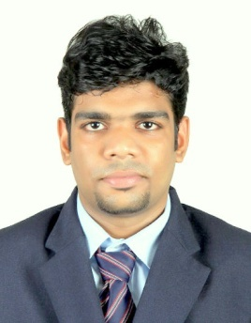
Viknesh
INDIA
Phone: C/o 971503718643
E-mail : vikneshvijayan@gmail.com

Objectives
To obtain a challenging position that will allow me to further utilize my skills. To work in an atmosphere favorable for leadership, innovative decision-making, mutual exchange of knowledge, further learning and thereby contribute to the growth of the organization.
Education
Post Graduate Diploma In Logistics & Supply Chain Management (2014 – 2015)
- Institution: London College of Business and Finance
- University/Board: CII-Institute Of logistics ,London College of Business & Finance

BBA (2011 - 2014)
- Institution: M.C Varghese College Of Arts And Science
- University/Board: Mahatma Gandhi University
Plus Two (2009 - 2011)
- Institution: Sacred Heart English Medium School, Changanacherry
- University/Board: Board of higher Secondary Examination
SSLC (2008 - 2009)
- Institution: Sacred Heart English Medium School, Changanacherry
- University/Board: Board of Public Examination

Professional Competency:
- Team worker with effective understanding of group behavior, effective leadership, problem solving and good presentation skills, conscientious and ability to work independently.

- Improved efficiency at work and work station utilization.

- Successful execution of requirements by internal and external customers.

- Escalation handling of external/internal customers.

- Good exposure in Marine Operations.

Professional Experience
- I have worked as SENIOR ASSOCIATE - Liner Operation. (1.11Years) at Maersk Global Service Centre

Achievements & Awards:
- Awarded as a TOP performer
- Got Best customer service award from the clusters.
- Awarded as Quarterly excellence winner

Personal Information
- Date of Birth: 16/03/1993
- Gender: Male
- Nationality: Indian
- Marital Status: Single
Skills
- Great communication skills:
Well-versed with the use of the Malayalam and English Language.
- Computer Knowledge:
Sufficient knowledge in the use of Microsoft office packages including MS word, MS Excel and MS PowerPoint.

Personal Traits
- Highly organized
- Self-confident, positive attitude.
- Willingness to work in team and hard work.
- Discipline and good etiquette.
- Good communication and interpersonal skills with good analytic power

Declaration
I hereby declare that the above mentioned details are true to the best of my knowledge and belief.

VIKNESH
Place: KOTTAYAM, Kerala

