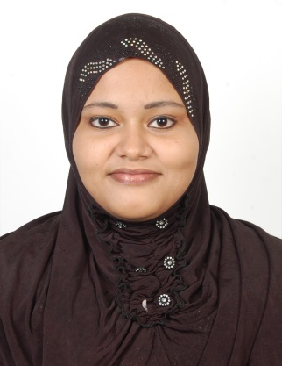
AREAS OF EXPERTISE
Financial administration
Office proceduresTyping & word-processing
Keyboard skillsFiling Reception dutiesDecision making
MS Office applications
SALMA
DUBAI, UAE

LANGUAGES KNOWN
English, Malayalam, Tamil,hindi,
Arabic is learning and wrieghting well

D.O.B : 14/02/1993 (24Years)

MARITAL STATUS: Married

NATIONALITY: Indian

BIRTH PLACE: KERALA, PALAKKAD

VISA STATUS: RESIDENTVISA(HUSBAND)

PHONE NO: +971505891826
Salma.378307@2freemail.com
PERSONAL SUMMARY
A team player, with a commitment to customer service, who possesses a long track
record of working in various administrative roles, coupled with good PC skills and
the ability to communicate confidently at all levels. Salma she has a highly organised
approach, plenty of initiative and a genuine desire to contribute to the ongoing
success of your Office. She has a reputation for delivering a high quality, personal
service to both junior and senior work colleagues. Apart from being immediately
available, she also has a strong background in general administration along with
experience of working within a customer focused
company like yours. Right now she
is looking for a key support role whereshe will have responsibility for the
administrative processes within the Office.
CAREER HISTORY
Garments exporting Company - kerala
OFFICE ADMINISTRATOR Jul 2011- 2013
Responsible for all the administrative processes within the Office, as well as
providing general secretarial support to enable the smooth and effective running of the office.

Duties:
• Following standardized company procedures relating to all aspects of Office
performance.
• Answering incoming calls in a professional manner.
• Maintaining suitable and sufficient office stationary levels.
• Establishing stationary requirements for the Office.
• Resourcing of candidates and appropriately advertising for and recruiting place-able
staff.
• Updating databases with confidential and relevant information.
• Sourcing candidates C.V’s from various job boards or other media sources.
• Ensuring that all information and documentation is compliant with guidelines of the Data Protection Act.
• Arranging interviews and confirming interviews by email.
• Coordinating and communicating social activities for the Office staff.
KEY SKILLS AND COMPETENCIES
Administration
• Able to use office equipment like copiers, fax’s, scanners & printers.
• Ability to type 30 wpm and demonstrated proficiencyon 10-key
.• Creating financial and statistical reports using spreadsheets.
Education
Higher secondery Diploma in multimedia
Computer skills : ms office ,word excel ,Photoshop ,illustator,coreldraw ,flash,
general knowledge of computer basics

DECLAIRATION
I PROMISED DECLAIRED I WILL BE LOYAL TO WORK AND CONSCIENCE

