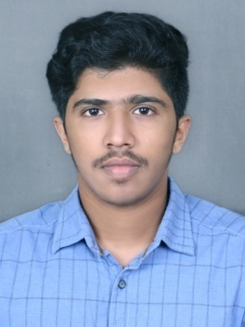

CURRICULUM VITAE
Charles
Mail: charles.378308@2freemail.com
C/o-Mob: +971 501685421

CAREER OBJECTIVE
Seeking a challenging and rewarding entry level Design, Manufacturing, Mechanical Engineer position in a growth-oriented organisation, which offers diverse job responsibility in Mechanical engineering and will fully utilise both my Technical and Managerial abilities.

EDUCATION
- Completed B.Tech in Mechanical Engineering from Cochin University of Science and Technology, in 2017
- Passed Senior School Certificate Examination from Central Board of Secondary Education in 2013.
- Passed Secondary School Examination from Central Board of Secondary Education in 2011.

PROFESSIONAL TRAINING
Had professional training in designing and analysis software’s like AutoCAD 2D, Ansys Workbench, Catia V5.

SUBJECTS OF INTEREST
- Automobile
- 2D and 3D designing using AutoCAD, Catia

PROJECT
Experimental case study of cascade refrigeration system using alternative refrigerants
Overview: Experimental evaluation of an R134a/R170 cascade refrigeration plant designed for low evaporation temperature in commercial applications.
Technical approach: Literature study was conducted and this knowledge was used to design and fabricate a cascade refrigeration system with refrigerants R134a & R170.
Key findings: The R134a-R170 is the best pair of refrigerants compared to others, as this system can be used for obtaining lower temperatures more effectively and is eco-friendly.
- Presented the academic project at national conference conducted by College of Engineering Adoor.

SEMINAR PAPER
Topic: Modernization of the turbocharger lubrication system of an internal combustion engine.
The seminar was based on the above paper, which discusses how to improve the operational reliability of engine turbochargers by its lubrication. We could see that by proper lubricating methods the turbocharger failure rates are reduced, improving the turbocharger and engine life.

STRENGHTS
Quick learner, Team Player, Adaptive, Trust Worthy, Honest, Friendly, Hard working

WEAKNESS
I prefer to deliver effective project, due to which I am not time conscious.

HOBBIES
- Reading, football, Music, Movies, Drawing

PERSONAL DETAILS
Date of birth - 31/05/1995
Gender - Male
Nationality - Indian
Visa Status - Visit Visa
Marital status - Unmarried
Languages Known - English, Malayalam (Read, Write, Speak)
Hindi (Speak)
Tamil (Speak)
Computer Proficiency - Microsoft office
(PowerPoint, Word, Excel)
Email, Social Networks,
Basic knowledge of C++

DECLARATION
I hereby declare that the above-mentioned information’s are true to my knowledge and I bear the responsibility for the correctness of the above mentioned particulars.

