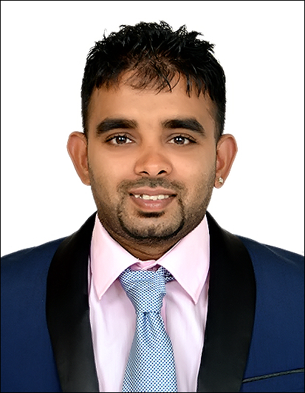
Arun
Al Qusais, Dubai, UAE.
C/o-Contact No.: +971 501685421
E-Mail: arun.378320@2freemail.com

Professional Objective
Seeking a challenging career in the quality environment where my technical skills and qualifications as an Electrical Engineer can be shared and enriched and make a significant contribution to organization with strong work ethics and diligence.

Professional Experience
Worked as anSafety Officer in Supreme Renewable Energy, India From June 2009 to December 2009.
Worked as an Sales Representative in Cost Cutter, London, United Kingdom From Jan 2013 to October 2015.
Worked as MEP SiteEngineer in Mangalam CADD Engineers,Puddukkotai From Jan 2016 to Dec 2017.

Professional Qualification
B.E (Bachelor of Electrical and Electronics Engineering) in the year 2009 with FIRST CLASS from AnnamalaiUniversity, Chidambaram.
P.G(Diploma in Electrical Safety and safety Management)in the year 2009 with FIRST CLASS from AnnamalaiUniversity, Chidambaram.
Academic(English level 2 ) and M.E.P ( Master Entry Program ) in the year 2011 passed from College of Technology London (CTL).
M.B.A –(International Business Management) in the year 2012 (1 year Completed) from college ofTechnology London (CTL).

Summary of skills and Experience
- Provide support for the health and safety management system, policies, programs, tools, and audit.
- Conduct training, field coaching, and assessment for safety performance improvement projects
- Monitors day-to-day safety performance by assisting with field audits, hazard identification and injury prevention
- Develop safety programs and policies through the Safety Manual, safety news, other safety related manuals, reports and videos
- Liaising with senior management as well as staff at all levels
- Supervising day to day site installation operations and solving problems raised during installation work.
- Preparing daily weekly and monthly work progress reports.
- Dealing with consultant and ensuring him about the daily work progress according to standard and design
- Budgets of purchase of spare parts, materials, tools for smooth and continues repair workflow.
- Daily check on machinery condition and operations on daily basis and taking recommended measures.

Working Experience
SUPREME RENEWABLE ENERGY

Worked as a Safety Officer in Supreme Renewable Energy (Power Transformer testing and service company) for 6 months (1 June 2009 to 30 December 2009) Cuddalore.

Roles and Responsibilities

- Demonstrated Proper use of safety equipment and facilitates to the people.
- Responsible for all aspects of health and safety within the factory
- Liaising with senior management as well as staff at all levels
- Conducted Safety Training and Educational talks to different offices.
- Ensured the safety equipment’s are installed in most accessible place in case of accidents.
- Keeping records, monitoring and reviewing all aspects of health and safety.

MANGALAM CADD ENGINEERS

Worked as a MEP Site Engineer in Mangalam CADD Engineers for 2 years (1 Jan 2016 to 30 December 2017) Puddukkotai.

Roles and Responsibilities
- Mobilization of manpower for execution of the project.
- Preparation of Daily, Weekly and One Month progress report.
- Coordinating Preparation of Bill of Quantities and floating the enquiries to the venders.
- Attending the weekly site meeting with consultant and sub contractors.
- Detailed study of scope of work, Specification, Equipment Schedule and BOQ (Tender) etc.
- Preparation of the detailed Site quantities requirement based on the consultants approved drawings.

Personal Profile
Date of Birth :09 /02/1987
Sex : Male
Nationality :Indian
Marital Status : Married
Languages Known :Tamil, English

I hereby declare that the above information given in this C.V is true to the best of my knowledgeand I shall stand in case of any discrepancies are found.

Arun

