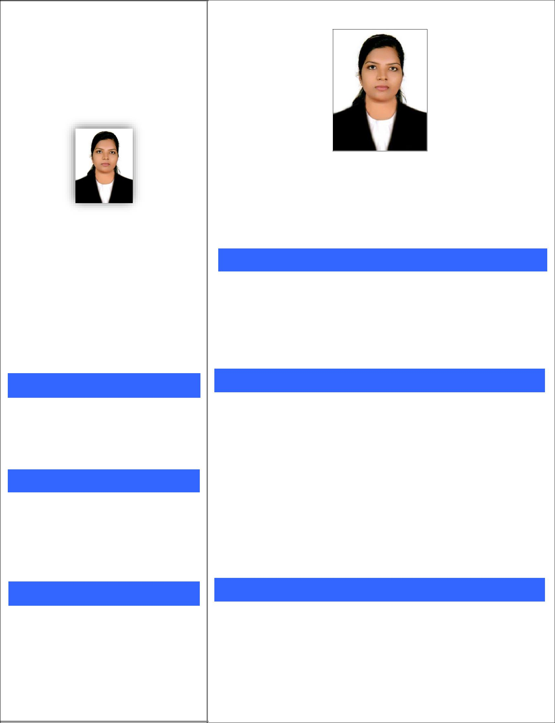

JINCY

C/o-Mob : +971501685421

Email:- jincy.378355@2freemail.com

PERSONAL DETAILS

DOB | : | 19.04.1992
Marital Status : |  | Married
Nationality | : | Indian

LANGUAGES KNOWN

- English

- Hindi

- Malayalam

- Tamil

PASSPORT DETAILS

Place of Issue : Trivandrum
Date of Issue : 02/03/2017
Date of Expiry : 01/03/2027
Visa : Visit Visa

JINCY

GENERAL PRACTITIONER DENTIST

(With MOH License)

OBJECTIVES

To be associated with a progressive organization in the service industry me challenges and opportunity to enhance my knowledge and sharpen my skills in accordance with latest trends.

EDUCATIONAL QUALIFICATION

BDS in Tamil Nadu Dr MGR Medical University (2009-2014)

Board of higher Secondary Examination From St. Mary’s Higher Secondary School, Trivandrum (2009)

SSLC Examination From Govt. HSS For Girls Cotton Hill, Trivandrum (2007)

EXPERIENCE

Worked as Intern in Sri Venkateswara Dental College

- Hospital for 1 Year(October 2013 – November 2014)

PERSONAL SKILLS

- Collaboration & Cooperation

- Strong listening skills

- Communication skills

- Self – Confidence & Mental Resilience

- Mentoring

WORKS

- Endodontics (Root Canal Treatment, Management of Avulsed Tooth, Crown Cutting, Composite Veneering, Composite Filling)

- Pediatric dental Care

- Periodontics (Splinting, Scaling &Root Planing)
- Prosthodontics (CD, RPD, FPD)

- Oral Surgery (Suturing, Extraction -Including third molars)

- Orthodontics (Bracket Placement, Modules Changing)

Worked as General Practitioner Dentist in Nirmala Hospital, Trivandrum for 2 years & 9 Months (June 2015 – February 2018)
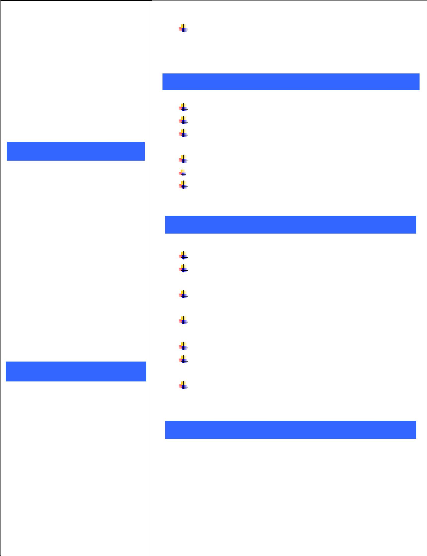

MANAGEMENT SKILLS

History and current affairs

Effective leadership

Identification of the best resources in order to achieve goals

Effective time management Prioritization

Worked as NABH coordinator in Nirmala Hospital.

STRENGTH & QUALITIES

A practical & systemic personality approach

Ability to motivate and inspire confidence in the team

Enthusiastic and dedicated to the companies objectives

Ability to perform under pressure and against targets

and deadlines

Dedicated, work smart

A ʽcan doʼ attitude. A strong aspiration to grow within the institution

Good communication and interpersonal, Self – Motivate

DECLARATION

I do hereby declare that the details furnished above are true to the best of my knowledge

Jincy

