IRSHAD
Java Android Developer
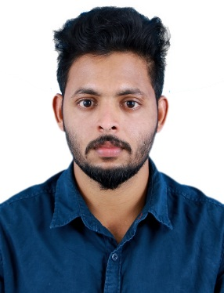

Irshad.378366@2freemail.com
C/o 971502360357

Career Objectives | A mature, Positive and Hardworking individual, who always strives to achieve the highest standard possible at any given task, To get Profession that is challenging,  Encouraging and other great deal of Exposure to Latest trends. Being a Person with  Determination and Dedication nature,Seeking a position to apply the knowledge that I have learned and explore abilities, skills, towards my duties and to excel in field of Java android and accounting. I will try my best for the betterment of the Organization
Skills | Java Technologies: Servlets, JSP  Frameworks: Struts, Spring, JSF  ORM Tool: Hibernate  Languages: JAVA,PHP  Platforms: Android  Web Technologies: Java Script, jQuery, Ajax  Web Server: Tomcat, Jboss, Glass fish  Operating Systems: Windows Family  Databases: MySql, Oracle  IDE: Eclipse, Net beans, Android Studio  Other: Tally ERP (VAT)
Work History | - Having 1 year of experience in developing Web and Enterprise Applications using technologies J2EE, JSF, Spring, Hibernate and Android App Develoment  - Hands on Experience in Core JAVA ,JDBC, Servlets, JSP, Ajax, JavaScript and JQuery  - .  - Hands on experience in usingGlassFish, Tomcat, Jboss servers  - Hands on experience in using Eclipse, Netbeans, Android Studio  - Experience in MySql database  - Good Team player and also have ability to work independently  - Adaptive to Learn New Technologies  - Easily mingle with any environment and hardworking nature  - Excellent programming skills in Java  - Excellent programming skills in Android
Education | Qualification University Year Percentage  BCA(Computer) Kerala University 2015 60.00%  H.S.E Kerala Board 2012 70.00%  SSLC Kerala Board 2010 72.00%
Employment Summary | - Has Worked with Right Soft Options as a Java and Android Trainer at Kochi  - Worked as Trainee(for 3 Months) at Logic Software Solution at Kochi

Passport Details
 Date Of Issue: 02/06/2016
 Date Of Expiry: 01/06/2026
 Visa Status :Visit Visa.

Project Summary

Project I :
Project Name: Online Organ Donation System

Team Size : 3
Profile: Team Member (Programming) & Client interaction
Technologies:Asp.Net & SQL Server

Project II :
Project Name: Student Information System

Team Size : 2
Profile: Team Member (Programming) & Client interaction
Technologies:JAVA (Core), J2EE, and MySQL 5.0

Personal Details

DOB : 14th October 1994
Sex : Male
Citizenship : Indian
Current Location : Cochin, Kerala
Hobbies : Travelling, Music, Football

Declaration
I hereby declare that the above statements are true and complete to the best of my knowledge and belief.

Date:
Place:
(IRSHAD)

