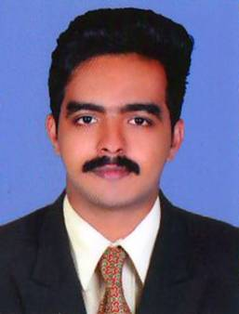
RESUME

CAREER OBJECTIVE
Seeking for the position of desktop support Engineer/ Networkengineer post from the challenging industry To be an excellent professional and utilize my knowledge and skills to the best of my ability so as to promote the growth of the organization
EXPERIENCE
DESKTOP SUPPORT ENGINEER IN CMS IT SERVICE LMTED
2016 JUNE -2017 FEBURARY
- Support the airline industrial application such as AIR NAV
- Technical support through voice process
- Outlook configuration and maintenance
- Manage and maintain Patch Management and server updates
- MS office installation and maintains
- Printer configuration and installation on both network other

JUNIOR NETWORK ADMINISTRATOR IN SOFTEN TECHNOLOGY
2015AUGEST – 2016 FEBRUARY
- Configuration and maintenance of Switches and Routers.
- Hardware maintains
- User account support for both system and outlook
- Data handling through folder access
- Installation, configuration and technical support of Desktops
- Maintaining the computer application and files from the institution
- Onsite technical support
OTHER EXPERINCE
- Sales executive in SONY INDIA PRIVETE ltd.
- Digital marketing expert for Mathew and sons pvt ltd.
EDUCATION
- BE COMPUTER SCIENCE ENGINEERING 2011-2015
ANNA UNIVERSITY CHENNAI WITH 6.83 of CGPA
- H.S.E. SCIENCE2009-2011
KERALA STAE BOARD WITH 72% of mark
- SSLC 2008-2009
KERALA STAE BOARD WITH 75 %of mark
AREA OF INTEREST

- Networking
- Window server administration
- Routing switching and security
- Desktop supporting
- Data entry operator
DECLARATION
I hear by declare that all the above mentioned details are ture to the best of my knowledge and self-belief

SOBIN

SOBIN JOSEPH

PLACE

SOBIN

CONTACT INFO

E-mail: sobin.378367@2freemail.com
Mob: C/o 971501685421

VISA STATUS

- VISITING VISA
- 3 months
- Expiring on March 26

SKILLS

- CCNA
- MCSE
- MSOFFICE
- DESKTOP SUPPORTING

LANGUAGES KNOWN

- English,
- Hindi,
- Malayalam

- Tamil

