Hafiz
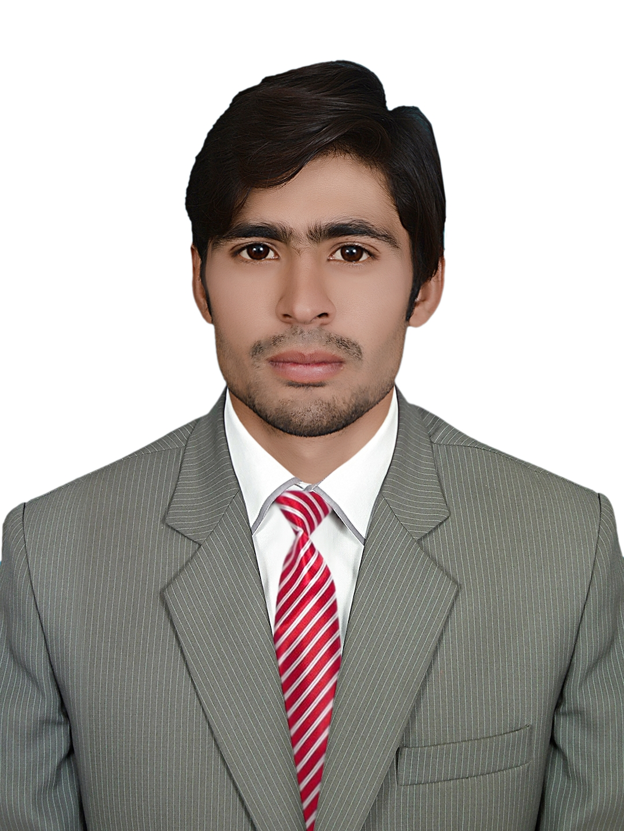

Hotel Management & Receptionist Professional
Cell: +971 503718643
Nationality: Pakistani
Email: hafiz.378392@2freemail.com
Address: Dubai

Career Objective

To contribute towards the growth and development of a dynamic organization where there are ample opportunities to grow both professionally and personally and where I can utilize my skills and experience efficiently and effectively.

EXECUTIVE PROFILE
- 1 Year experience at Pearl Continental Hotel Lahore as a receptionist having record of quality work performance in the company.
- 6 month experience as guest relation officer having good record of customer satisfaction.
- 6 Month Multiple experience in event management, laundry management, Housekeeping management, Room division, Butlers services, Business centre and concierge department as a internee in Pearl Continental Hotel a biggest 5 star chain in Pakistan.
- Gained intensive experience in handling wide range of customer satisfaction and accommodationoperation and services including guest check in, check out and solve the queries of customer.
- Equipped with presentation and report writing skills and an expert user in Micros, Opera V5, Hotel eye with excellent skills in office applications like MS Excel, MS Word, MS PowerPoint.
- 2 year experience at Layzal tech call centre as a Communication officer having good record of quality and communication.
1.5 year experience at Mall Of Lahore as acustomer services representative.
STRENGTHS
Strong verbal and written communication skills. Expert user in Micros, Opera V5, Hotel eye.
Punctual, hardworking and enthusiastic. Expert in MS Office.
Effective compliance to SOP and controls. High Level Analytical Aptitude.

PROFESSIONAL EXPERIENCE
Layzal Tech Call Centre Lahore
Communication Officer (June 2011 – september 2013)
Layzal tech call centre a outbond call centre in Pakistan which worked for Security Alarm Systems In Canada.Call Centre Giving All information to the people about alarm system .
My Responsibilities at the company were:
- Calling to the Customer.
- Arrange Meeting with the customer.
- Sale to the customer.
- Handling the complain of Customer
Mall Of Lahore Shopping Centre

Customer Services Representative (January 2014 – August 2015)
Mall of Lahore a biggest Shopping centre chain in Pakistan.The Mall with the vision of Providing quality and all the things which we need in daily life.The Mall of Lahore Provides all the famous International brands to the Customer as well as entertainment and Lots of food chains.
My Responsibilities at the company were:

- Interact with the customer .
- Provide information to the customer.
- Response to Inquiries About Products.
- Saving the record of the customer as well as feedback.
- Handling the complain of Customer
Pearl Continental Hotel (PC), Lahore Pakistan

Guest Services Officer (June 2016 – July 2017)
Pearl Continental Hotel a biggest chain in Pakistan, It is a luxury 5-Star hotel. The hotel with the vision of providing quality event management, accommodation, operation and services.
My Responsibilities at the company were:

- Check in the customer.
- Check out the customer.
- Reservation of the customer.
- Welcoming and look after the Guests.
- Handling the complain of Guests.
- Complete audit at the time of check out as required.

Hilton Hotel&Resturant Lahore, Pakistan

Guest Relation Officer (July 2017– Dec 2017)
Hilton Hotel Lahore a company of hotel and restaurants which established in 2009. The company provide accommodation operation and services, event management, providing continental food and traditional food.
My Responsibilities at the company were:

- Managing the guest from receiving to sitting.
- Handling the guests.
- Handling the queries of guests.
- Handling the complaints of the guests.
- Check and balance of all the restaurant staff.

COMPUTER AND OTHER SKILLS
- Micros
- Opera V5
- Hotel eye
- MS Office 2007,2010,2013.
- Munchi 7 to 11
PROFESSIONAL QUALIFICATION
- Hotel Management Diploma (Accomodation, Opration and Services from Hashoo foundation, Pearl Continental Hotel Lahore).
- Hotel Management Training Program from NTB (National Training Bureau Govt of Pakistan)
- Diploma Of ROS (Specialisation in reception opration and services)
- Diploma of Reception Opration and Services certification from City & Guilds (UK).
- 2 Month Conversation class from British Education Training System BETS.
EDUCATIONAL QUALIFICATION
M.A Pol-Sci (1) Punjab University Lahore
B.Com- The University of Punjab-Lahore
I.Com – Bise Sahiwal
Matriculation – Science (Multan Board)

PERSONAL INFORMATION

Date of Birth | April04, 1994
Marital Status | Single
Relocate | Upon discussion

REFERENCE:
Will be provided on demand

