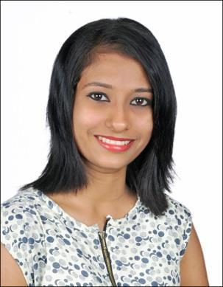

RAKSHITHA

C/o-Cell No:+971504753686

Email ID: rakshitha.378397@2freemail.com

Career Objective:

Looking for an organisation where I can enhance my skills and knowledge and to work for the growth of the organisation.

To succeed in an environment of growth and excellence and earn a job which provides me job satisfaction and self development and help me achieve personal as well as organizational goals.

Educational Details :
 | Course |  |  | Year | Institution | Percentage/CGPA
 | MBA (Human Resource) |  |  | 2015-17 | Sahyadri College of | 71%
 |  |  |  |  | Engineering and
 |  |  |  |  | Management Mangaluru
 | B.B.M |  |  | 2012-15 | K.S.Gowda First Grade | 74.22%
 |  |  |  |  | College Ninthikal
 | PUC |  |  | 2010-12 | SSPU College | 66.66%
 |  |  |  |  | Subrahmanya
 | S.S.L.C |  |  | 2010 | Vidyabhodhini High | 74.4%
 |  |  |  |  | School Balila
 | work Experience :
 | Company Name |  |  | Designation | From – to | Years of experience
 | Anupama Feeds & Farms |  |  | Assistant HR | 01/09/2017-30/11/2017 | 3 month
 | kulshekar, Mangaluru
 | Internship :
 | Company Name : HDFC Life
 | Duration | : 4 weeks
 | Title |  |  | A study on customers preference towards Insurance product
 |  |  |  | marketed by HDFC life Mangaluru
 | Deliverables |  |  | • To study number of insurance product marketed by

HDFC life
- To study customers awareness about insurance

Company Name : Scotts Garments Limited
Duration | : 10 weeks
Title |  | A study on impact of multigenerational differences on
 |  | motivation of employees at Scotts Garments Limited bengalore.
Deliverables |  | • To identify the factors influencing multigenerational
 |  | differences.
 |  | • To evaluate the impact of multigenerational differences
 |  | on motivation at workplace.
 |  | • To suggest measures if any to eliminate the
 |  | multigenerational differences.
Achievements :
Scholastic Activities:

- Participated in inter collegiate dance competition conducted by Mangaluru University.

- Participated in Cultural Activities in college.

- Actively participated in social awareness activities which is conducted by K.S.G.College Ninthikal

- Actively parcicipated in Neurolinguistick programming (NLP) which is held at college of social work, roshini nilaya.

- Participated in one day seminar about(shraddha) education for self-reliance which is held at ramakrishna math, mangaladevi mangalore.

Extra-Curricular:
- Won prize on inter class dance competion held by KS Gowda first grade college

NINTHIKAL.

Personal Dosseir :
Date of birth | : 17-06-1994
Gender | : Female
Nationality | : Indian

,

Languages known

: English , Kannada , Hindi , Tulu

Skills :

- Ms-Office

- Basic accounting

- Saral pay pack

- Recruiting

- Manpower planning

- Time attendance

Acknowledgement: The above mentioned details are true to the best of my knowledge

