Mahmoud
Mob:+971-505891826
E-mail: mahmoud.378398@2freemail.com
ـــــــــــــــــــــــــــــــــــــــــــــــــــــــــــــــــــــــــــــــــــــــــــــــــــــــــــــــــــــــــــــــ
Objective :
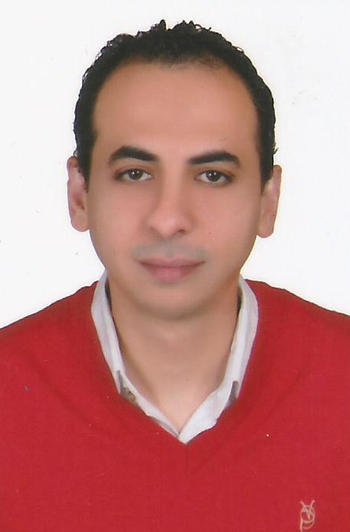
Looking for the job that offers personal growth opportunities for contributing to the growth of the organization.

Profile :
- Dedicated to the assigned job.
- Sincere, honest & possess friendly nature.
- Eager to learn more & more.
- Able to work under pressure.

Personal Data :
Date of Birth: 01/04/1980
Place of Birth : Alexandria
Sex : Male
Nationality : Egyptian
Religion : Muslim
Marital Status: Married
Languages Known: Arabic & English
Permanent Address : 25, Ibrahim El Attar Street, Zizinia, Alexandria- Egypt

Courses:
- Diploma in sales and marketing

Work Experience:

- Working at Global Company for cars as customer service for two years.

- From 2006 Till Now Owner&FounderNeTJeT Company for integrated solutions, import & Export.
- From 2006 Till Now Sales & Marketing ( Computer – Mobile Phones – Real State – Copy Machines – Electrical Devices - Agricultural machinery–Apparel –Tools and kitchen appliances – Toys - Etc.).
- From 2006 Till Now maintenance and repair computer software & hardware.
- From 2002 Till 2009 maintenance and repair mobile phones software & hardware.
- From 2008 Till 2010 Owner&Founder(Egyptian Arab academy ) for Computer & Languages courses.
- Experience all the administrative affairs office and secretarial (More than 16 years' experience in secretarial and administrative work (for all secretarial work print Arabic and English) + possibility translator to reply to all books, correspondence and sending faxes and emails and work contracts and quotations, orders and coordinate files and work filling system + knowledge of the affairs of human resources and personnel files + preparation and processing of tenders.
- Clear all government transactions, embassies, consulates and customs

Computer Skills:
- Operating System Windows XP,7,8, 10.
- Microsoft Office 2003, 2007, 2010, 2013.
- Internet.
- Data Entry.
- Setup Software & operating system Windows XP,7,8, 10.
- Maintenance hardware
- Upgrade Computer's hardware.

Language Skills
- Arabic : Native
- English : Excellent (Writing ) , Very Good ( Speaking )
- Italian : Fair
I hereby confirm the Correctness of the above furnished particulars.

