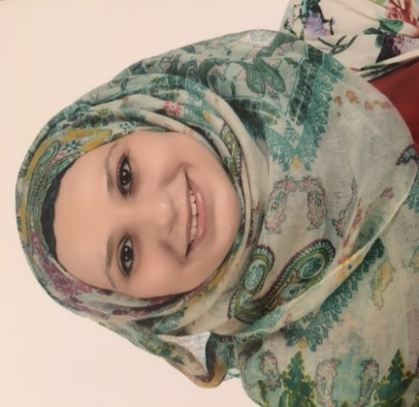
NAME: Hawazen
Email Address: hawazen.378404@2freemail.com
Gender: |  | Female
Birth Date: |  | 31 December 1987
Nationality: |  | Jordanian
Visa Status: |  | Resident
Residence Location: |  | Dubai
Marital Status: |  | Married
Driving License: |  | Jordan – UAE
Mobile Phone Number: +971505891826
Location: Dubai

Personal Information

Career Objective

 | I am seeking a position where I can further progress my linguistic knowledge and technical skills employing my knowledge in English language or any other related skills in management.
Target Industry ( double major) : | Applied Linguistics ( M.S.)- English & Spanish languages literature (B.S.)
Employment Type: | Translator ( general and legal documents)  & researcher  & any position related to the field of study
Employment Status: | Full time
Target Monthly Salary: | According to the company staff

Professional Experience
- Researcher & Translator at PRUNZ for research  Wadi Saqra Street, Amman , Jordan | January-November 2014
- Researcher & Translator at IFRAD -  King Raniya Street, building No. 197, Amman, Jordan  Company Industry: Education, Training, and Library  Job Role: Researcher  Duties:  - Research to help students translate and write the studies or researches that they need to complete their education.  - Research and prepare Master and Ph.D. dissertations. So that I have ;  - Comprehensive and thorough knowledge on the field or subject of specialization.  - Knowledge of common referencing styles. Example: Harvard, APA, Chicago, MLA.  - Excellent research and analytical skills.  - Outstanding comprehension of current issues  - Ability to choose relevant and appropriate research resources and materials, with knowledge of peer journal article databases to use.  - Ability to present thoughts clearly and coherently  - Fluent in English, articulate and able to write well in English | March2010- September 2013
- Translator,  Al Huda for translation  Al- Abdalli – Amman  Company industry : translation  Job Role: translator | August 2010 –  February 2011

Education

- Jordan university of science & technology , Irbid , Jordan  Master degree ( English) DEGREE : very good | September 2011 –  2014
- Jordan university, Amman, Jordan  Bachelor's degree/higher diploma ( English & Spanish language ) DEGREE : very good | September 2005-  June 2009

Courses:
  - TOFEL EXAM 2005-2007
  - IELTS EXAM (NOT YET)

Career Level
Career Level: | Mid-Career
Notice Period to Work: | Immediately
Last Monthly Salary: | JD 400

Skills

Skill Years of Experience Skill Last Used
Level
Microsoft Office software & the Internet | More than 10 years | Expert | 1 month or  less

Languages

Language Years of Experience Skill Level Last Used
English | More than 5 years | Expert | 1 month or less
Spanish | 2 years | Moderate | During study period
German | 1 year | Weak | Before 3 years

* All documents will be furnished once needed.

