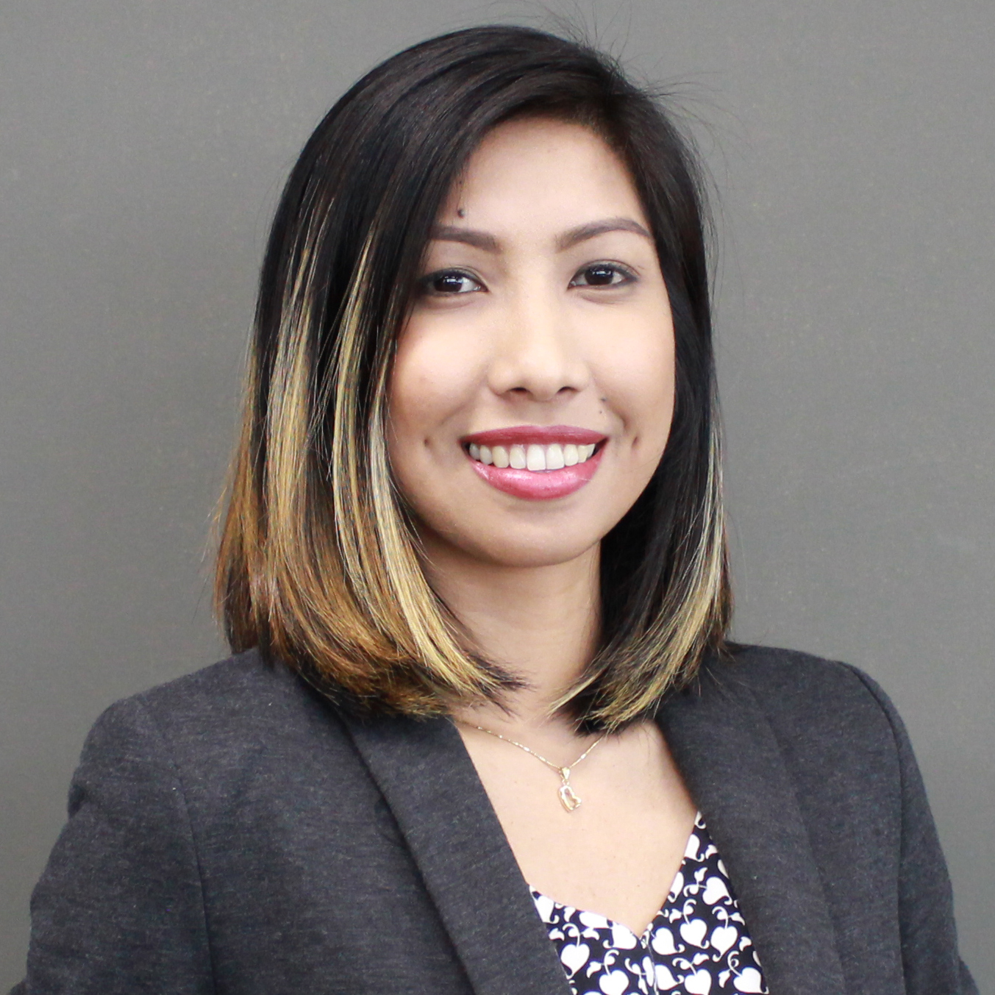KAREN
Dubai, UAE
C/o-Mobile No.: +971502360357
E-mail : Karen.378408@2freemail.com

OBJECTIVE:

To obtain a Full-time position where I can apply all the skills learned from experience, impart my ideas, perform the job assigned to and attain a high level of performance as well as to have excellent career growth opportunities.

PERSONAL PROFILE:

Visa Status : Cancelled
Date of Birth : August 26, 1991
Civil Status : Single
Height : 5’4”
Weight : 45kg
Religion : Christian
Nationality : Filipino
Language : English, Tagalog
License : UAE Driving License

EMPLOYMENT HISTORY:

3D Visualizer /Interior Designer
Future Sky Interior & Decoration LLC – Dubai, UAE
November 2014 – February 2018
- End to end interior design of different offices utilizing 3DS Max and AutoCAD software
- Developing drawings from concept to technical detailing and support in all aspects of design presentations
- Preparing shop drawings
- Space planning
- Site survey to obtain necessary information prior to design

CAD Engineer - Team Leader – (3.5 YEARS)
One’s Philippine Epoch Corporation – Makati City
January 2010 – June 2013
- Japanese base company engages primarily in Architectural Engineering and Design services.
- End to end architectural design of different Japanese residential houses ranging from Simple modern, Urban, European, Japanese Modern and traditional style, utilizing in-house company software called One’s Planner, equivalent to AutoCAD
  - From 3D presentation, to working drawing; a complete design from architectural, electrical wiring and foundation plan.
- Helping with training and development
- Project and time management
- Read and interpret blueprints, technical drawing, schematics and computer generated reports
- Analyze blueprints and other documentation to prepare cost, materials, and labor estimates using AICA Estimation System and One’s Mitsumori System software
- Convert sketches or specifications of the project into detailed CAD drawings
- Electrical wiring design of houses
- Make layouts and estimation of materials for residential constructions in Japan using Japanese Software:
  - AutoCAD 2008
  - One’s CAD
  - JW CAD

Project Engineer – (1.2 YEARS)
First-AVPR Venture, Inc. – Pasig City
July 2013 – September 2014
- Company engages primarily in Compressed Air/Gas & Water Treatment, Separation & Purification
- Gas Plant Piping design and 3D layout using AutoCAD 2014
- Estimate Bill-of-materials and installation costing
- Project supervision on-site

SKILLS AND QUALIFICATIONS:

- Proficient in Computer Aided Designs (AutoCAD 2015)
  - Creates 2D and 3D designs – Color Rendering for more realistic effect
- Knowledge in Adobe Photoshop, 3DStudio Max and V-ray rendering
- Proficient in Microsoft Office Word, Excel and PowerPoint, and Internet
- Eager to learn new skill, willing to be trained and travel anywhere
- Exceptional capacity to multitask
- Possesses computer operation skills

EDUCATION:
MFI Technological Institute
Industrial Instrumentation
College Graduate, 2010

TRAINING / CERTIFICATION:
Microcadd Institute Inc. (AutodeskAuthorized Training Center)

- AutoCAD 2013 Comprehensive (2D and 3D Computer-Aided Design, Drafting and Color Rendering)
- 3D Studio Max 2014 for Architectural Design

LECTURE-WORKSHOPS ATTENDED:
- MFI TECHNOLOGICAL INSTITUTE
  - Work Attitude Program Review
  - Stress Management Seminar
  - Work Orientation Workshop
  - Lifestyle Management Seminar Workshop

