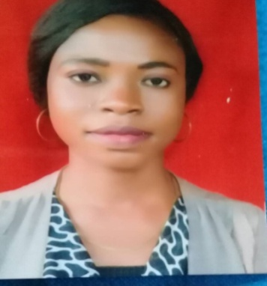
CURRICULUM VITAE

EVELYN

C/o-Tel: +971503718643

Email: evelyn.378412@2freemail.com

PERSONAL DETAILS
Date of birth: 21-09-1988

Nationality: Nigeria

Sex: Female

Languages English, Youruba

Job Objective: To secure the position of baker and cake Decorator in a reputable company that will allow me to utilize acquired skills and experience.

Highlights
- Over nine years of baking and cakes decorating inlager and small events both formal and informal
- Substantial experience of decorating, piping and presenting cakes
- Extensive knowledge of bakery ingredients, cake decorating tools and food processors
- Commendable knowledge of food safety standards, sanitation policies, and health regulations
- Familiarity with applying icing, frostings, toppings, and fondants ability
- to read, comprehend, and follow recipes, correctly
- Ability to interact and work with all members of bakery team, in a positive manner
- Baking of cookies, pies, bread,cupcakes,dessert ,doughnut and pastries
Professional Experience:
Mix n Bake Confectionery & School 2010 – 2017
Head of Operations department
Responsibilities:
- Responded to customers’ query calls and took orders, in a prompt and professional manner
- Prepared, decorated, and packaged all varieties of cakes and cake products, efficiently.
- Proving training and seminars on baking and cake decorating techniques
- Priced, stored, and showcased all decorated cakes, as per department procedures and guidelines.
- Ensure cleaned, tidied, and organized all assigned sales counter and work areas.
- Completed and delivered all decorated cake orders to clients, on time.
- Developed and maintained cordial relationships with all coworkers and clients.
Major Accomplishments
• Organized workshops and seminars on cake decoration and various baking techniques
(Modeling, sugarcarft, royal icing, sugar paste and piping)
Exotique Cakes 2007 – 2010
Cake Decorator
Responsibilities:
- Assisted with preparation of cakes and executed all cake decoration activities, as assigned.
- Completed and submitted all cake production sheets, accurately and on time.
- Used and cleaned all culinary and decorating equipments, properly.
- Cleaned, sanitized, and organized all assigned kitchen areas and workstations.
- Interpreted and adhered to established health, sanitation, and safety standards and procedures.
- Developed and maintained strong professional relationships with team members, production staff, and other departments.
Education
- Bachelor of Science in Economics 2011 – 2015
Lagos State university
- Senior secondary school certificate 2006
- First school leaving certificate 2000
Technical Qualification
- Diploma in Sugar craft and cake decoration 2011
- Advance Diploma in Modeling and cake making 2013

