Curriculum Vitae

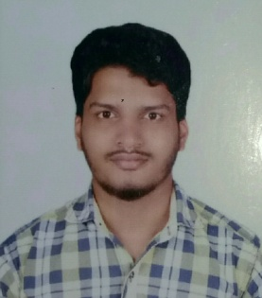

ABHISHEK

C/o- +971501685421
Email – abhishek.378419@2freemail.com

CAREER OBJECTIVE:

To pursue a challenging career in an organisation where I can enhance my skills through a continuous learning process, utilise my knowledge and determination to add value symbolically and hence prove myself as an asset to the organisation.
EDUCATIONAL QUALIFICATIONS:

QUALIFICATION | YEAR OF PASSING | SCHOOL/COLLEGE/INSTITUTE | BOARD | PERCENTAGE
B.E(Electronics & communication  Engineering) | 2017 | Vivekananda College of Engineering And Technology, Puttur | VTU, Belgaum | 60.52
12th | 2013 | Milagres PU College Mangalore | Karnataka P.U Board | 61.16
10th | 2011 | Sirajul Huda  EMHS Manjeshwar | Kerala State Board | 75

TECHNICAL SKILLS:

- Basic C Programming
- Knowledge of Analog/Digital communication systems and modulation techniques.
- Knowledge of wireless communication techniques(FDMA,CDMA,TDMA) and industry standards(3G,WLAN,IS-136,GSM,LTE).
- Knowledge of Embedded system.
- Good knowledge of circuit boards, processors, chips, electronic equipment, and computer hardware and software.
- Hardware programming VHDL and Verilog.

Operating System
Windows 7,Windows 8,XP,Linux.

STRENGTH & SKILLS:

- Committed
- Quick Learner
- Sincerity
- Positive attitude and well determined
- Discipline

Language Skills
Spoken fluently : English, Hindi Malayalam & Kannada

Hobbies
Hearing Music, Browsing, Traveling.

PROJECT:

Title : Multipurpose Embedded Kit
Description : Multipurpose Embedded kit is the computing system with a dedicate function within a large electronics system.Used as a automation in home appliances. The usage of kit reduces the man power as well as the time consumption.

CO-CURRICULAR ACTIVITIES :

➢Actively participated in Poster Presentation competition of Jnanasangama-2017 conducted by VCET Puttur in year 2017.
➢Actively participated in Paper Presentation at NCIS-2017 conducted by School Of Information Sciences,Manipal University in year 2017.
➢Actively participated in Circuit gallery conducted by VCET Puttur in year 2016.
➢ Completed Value Education Exam conducted by Mangala Jyothi in year 2011.

PERSONAL DETAILS:

Date of Birth : February 5th, 1996
Gender : Male
Nationality : Indian
Marital status : Single
Visa status : On Visit visa

