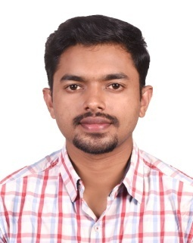
THOMAS
C/o-Mob : +971501685421
Email : Thomas.378436@2freemail.com

PROFESSIONAL PROFILE

Seeking an opportunity to work with an organization that will provide an enriched platform to utilize my technical skills and enhance my knowledge to help in the progress of organization and self –growth.
EDUCATIONAL QUALIFICATION

GRADE | NAME OF INSTITUTION | YEAR
B.Tech in Applied Electronics and Instrumentation | Saintgits College of Engineering, Kottayam  (MG University) | 2016

WORK EXPERIENCE
- One year Working Experience in KENS Industrial Tool Roomas Sales Engineer
- Industrial Training at KELTRON, Trivandrum
- Attended a training program on PLC and SCADA conducted by YOKOGAWA India Ltd.
JOB RESPONSIBILITIES
- Responsible for improving Sales
- Office administration
- Responsible for Procurements necessary for the new works
- Calibration of Instruments.
- Provide technical support to the staff as and when required

TECHNICAL KNOWLEDGE
Completed a PG Diploma Training on Industrial Automation which includes Field Instrumentation, PLC SCADA , VFD, HMI, PAC, DCS, Electrical controls and panels
Knowledge inC, C++, basic SQL,Microsoft Office
Relevant knowledge in MATLAB, Adobe Photoshop
Basic knowledge in various networking areas including LAN, WAN, Windows OS, Servers, Switches, Firewall, Desktop etc.
Embedded systems (microcontroller 8051, 8086, 8085)
PERSONALITY TRAITS
- Dedicated and Diligent
- Good Communication Skills
- Confident and Optimistic
- Willingness to learn and grow
CO-CURRICULAR ACTIVITIES
- Event Head of NAKSHATRA 2015, National level Techno-Cultural Fest held at Saintgits College of Engineering
- Event Head of SFERICS 2015, inter-college tech fest held at Saintgits College of Engineering
TRAININGS, PROJECTS AND SEMINAR
- Semester Project on Automatic Street Light
- Mini Project on Marine Beacon
- Main Seminar on LcosTechnology
- Main Project on Gesture Controlled Wheelchair
PERSONAL DETAILS
Nationality : Indian
Date of Birth : 25-11-1994
Sex : Male
Languages Known : English, Hindi and Tamil

