Ahmed
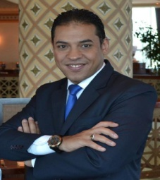

 |  | C/o-Mobile: - +971503718643
 |  | E-Mail:- ahmed.378448@2freemail.com
Date of Birth: - 25 / 05 / 1979
Military Service: - Performed |  | Nationality: - Egyptian
Objectives:-

Seeking a challenging and interesting position with responsibilities matching and exceeding previous experience, where my academic background and understanding can be utilized and developed

Personal Skills:-

Very good communication Skills Ability to work under pressure
Self-motivated , dependable and goal oriented Good presentation skills

Ability to work individually and as team member

Language Skills:-

Native fluency in Arabic Language

Very Good command of written and spoken English language

Computer Skills:-

Proficient In Microsoft Office (Word – Excel – PowerPoint – Access) , M.S Project & Internet Fidelio as a Hotel System ( Version 6.2 )
Opera as a Hotel System FMC System

Education:-

Secondary Commerce School

Experience:-

Le Royal Meriden Cairo Hotel , Housekeeping Attendant from ( 01/05/2001) To (01/12/2002) Royal Nile Tower Cairo Hotel , Housekeeping Attendant from ( 01/01/2003) To (20/08/2003) Grand Hyatt Cairo Hotel , Housekeeping Team leader from ( 21/08/2003 ) To (21/06/2008)
Sheraton Khalidia Abu Dhabi UAE as Senior floor supervisor from ( 26/06/2008) To (15/11/2008)
Grand Hyatt Doha Hotel and Residences, Pre opening Housekeeping Team leader from. (18/11/2008) To (21/2/2010)
KemPinski Nile hotel Cairo Hotel, as A Butler (19/06/2010) till (15/05/2011)

ABDALLAH A. M. AL.KHODARI SONS CO At Saudi Arabia As Camp Manager from (25/05/2011) Till ( 26/03/2014)
Al Shalawi international holding company for trading & contracting As Camp Manager From (11/05/2014) to (17/03/2016) working with Aramco projects.
Rosewood Jeddah Hotels, As Housing Manager. From (19/05/2016) Till now.

