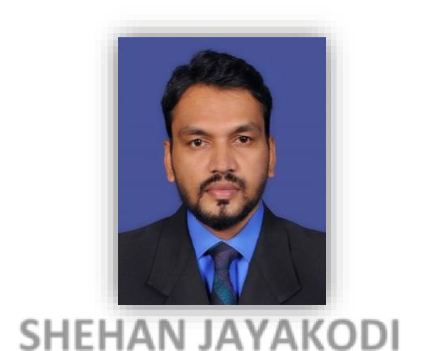

SHEHAN

QUANTITY SURVEYOR

PROFILE

Construction Professional with 8 years of Experience in Construction Environment in Infrastructure & Building Projects.

Most importantly as a self-motivated team player I hope to actively participate and Contribute

towards the organization’s improvement and development

CONTACT

Dubai

United Arab Emirates +971 501685421
shehan.378450@2freemail.com

EXPERTISE

Variations, Estimating & Budgeting, Negotiations, Teamwork, Leadership, Time Management, Verbal & Written Communication

COMPUTER LITERACY

MS-Office

MS-Project

Auto CAD

Access Guide (Costing)

DOCUMENT

FIDIC (1999, 1st Edition)

CESMM 3

SMM 7

POMI

SLS 573

 |  |  |  | CURRICULUM VITAE
 |  |  |  | PERSONAL DETAILS
 |  | Name in Full :- |  | Shehan
 |  | Date of Birth :- |  | 26th August 1985
 |  | Gender | :- | Male
 |  | Civil Status | :- | Single
 |  | Nationality | :- | Sri Lankan
 |  | Visa Status | :- | Visit Visa

PROFESSIONAL EXPERIENCE

EMPLOYER 01

QUANTITY SURVEYOR

July 2017 – December 2017

S & K ENGINEERNG ENTERPRISES PVT LTD

Company Profile :-

M01 (ICTAD) Type Company Deal with Building & Infrastructure Projects.

Project Involved :-

Central Express way Project Section 2 from Meerigama to Kurunegala, Srilanka

EMPLOYER 02

QUANTITY SURVEYOR

December 2014 – July 2017

CHINA NATIONAL AERO TECHNOLOGY INTERNATIONAL ENGINEERING CORPARATION LTD (CATIC ENG)

Company Profile :-

International Engineering Construction Company which Designs, Contract and Constructs Various Public, Civil and industrial Projects in all Over the world.

Project Involved :-

Improvement & Rehabilitation of Ratnapura karawita Road (B390) - Priority Road Project 03, Srilanka

U$D 75 M

U$D 4.5 M

U$D 4.3 M
EMPLOYER 03

QUANTITY SURVEYOR

October 2011 – December 2014

February 2007 – February 2009

MAGA ENGINEERING PVT LTD

Company Profile :-

M01 (ICTAD) Type Company Deal with Building & Infrastructure Projects.

Project Involved :-

CP05 Road Project (B268) Manipay to Kaithady, Sri Lanka -Value

A35 Road Project Paranthan to Mulathive, Sri Lanka -Value

MU1 Road Project Puthukudiyiruppu to Mulathive, Sri Lanka-Value U$D 4.5M Ceylinco Celestial Residencies Building, Colombo, Sri Lanka-Value

DUTIES & RESPONSIBILITIES

- Taking Off Quantities from Auto Cad Drawing & Site Measurements.

- Preparation of Monthly Interim Payment Application and liaise with the Engineer to obtain Payment Certificate timely.
- Preparation of Final Account with all Supporting Documentation.

- Evaluate the Unit Rates for new work items, Recording the Detail and Monitoring the day work Process and Preparation of Variation.

- Price / Forecast the Cost of different material need the Project.

- Preparation, Evaluation, Negotiation and Reporting Claims.

- Monitor Cost against with Budget and Preparation Progress /Cost Reports.

- Prepare Completion Certificate for the Completed Scope of work by the Sub-contractors.
- Monitoring Progress of work & Prepare Monthly Progress Report.

PROFESSIONAL QUALIFICATIONS

- 2008 – 2011 National Certificate in Technology (Quantity Surveying)

NCT QS

Technical College, Warakapola, Sri Lanka.

➢ | 2009 | Microsoft office Course
 |  | The Golden Key Institute of Information Technology
 | . | Kegalle, Sri Lanka.
➢ | 2006 | Certificate in Electrical Mechanical
 |  | National Youth Service Council, Kegalle, Sri Lanka.

LANGUAGE SKILLS

English

Sinhala

EDUCATIONAL

Passed - General Certificate of

Education (Advanced Level)

Passed - General Certificate of Education (Ordinary Level)

I do hereby Certified that the above information is true and correct to the best of my knowledge.

Yours faithfully.

Shehan

