Curriculum Vitae

TARIQ
IT, Computer Systems and Networks
Customer Service and Support

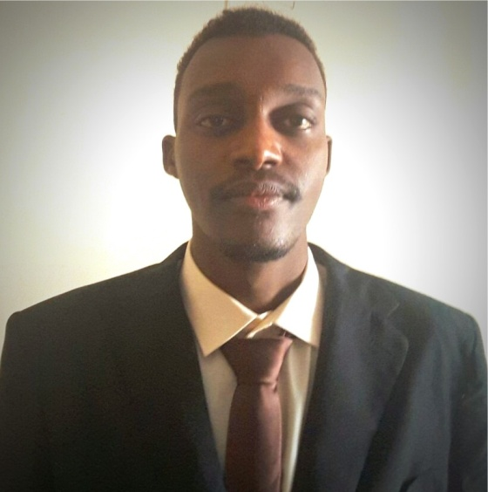

PERSONAL INFORMATION | Male.  Born on 1 January 1991.  State of Born Kusti.  Nationality; Sudanese.  Current Address:Al Sharijah  C/o-Tel. +971502360357  Visa Status: Visit visa  E-mail: tariq.378453@2freemail.com  Sudan – Khartoum
OBJECTIVES | To extend my knowledge of Networking and Computer programming, to gain work experience and to be useful to my employer and colleagues at a maximum range as possible.
ACADEMIC QUALIFICATION | Bachelor degree "honor" of Computer Systems & Networks  , Sudan University of Science and Technology "SUST" March 2015, Third Class. Khartoum, Sudan.
ACADEMIC SKILS | -Networking (Routing & Switching, Cabling, Testing).  - Android Development.  - Java.  - HTML  - PHP  - CSS  - JavaScript  - MYSQL  - CCTV Knowledge
OTHER SKILLS | - Strong verbal communication  - Customer Service Orientation  - Problem Solving  - Very good communication in English language reading, writing and speaking.  - Excellent in Arabic Language (Mother language).  - Avery good skill at teaching.
COMPUTER LITERACY | - Operating Systems  - WINDOWS SERVER 2008/2012  - Client XP/VISTA/7/8/2010  - LINUX (REDHAT, UPUNTU)  - Microsoft Office 2003, 2007, 2010, 2013  - VMWARE Knowledge
GRADUATION PROJECT | - Restaurants Delivery System (Website + Android App).  - The system contains multiple restaurants.  - The customer can search for the restaurant he wants to order from and he can see the bill and modify his order then proceed his order.  - The customer can order by Website or Android App, when he orders by the Android App then the App sends the customer's current location info to the restaurant, using the phone's GPS.  - Customers can send feedbacks about a particular restaurant.
WORK EXPERIENCE & TECHNICAL TRAINING | - Trainee At ALBARKA BANK, IT Department Network department AS IT Technical Support Six Month Certified from 17/1/2017 to 17/2/2017  - install and configure computer hardware operating systems and applications  - monitor and maintain computer systems and networks  - talk staff or clients through a series of actions, either face-to-face or over the phone, to help set up systems or resolve issues  - troubleshoot system and network problems, diagnosing and solving hardware or software faults  - replace parts as required  - provide support, including procedural documentation and relevant reports  - follow diagrams and written instructions to repair a fault or set up a system  - support the roll-out of new applications  - set up new users' accounts and profiles and deal with password issues  - respond within agreed time limits to call-outs  - work continuously on a task until completion (or referral to third parties, if appropriate)  - prioritise and manage many open cases at one time  - rapidly establish a good working relationship with customers and other professionals, such as software developers  - test and evaluate new technology  - conduct electrical safety checks on computer equipment.  - Work in I&S Group (Intelligence & Services Engineering) Network Department AS Network Technician From 1/10/2016 Until 10/1/2017.  - Trainee in Networking and Server Administration  - Passive Networking(Cabling).  - Working at Sudanese Organization for Standardization and Metrology (SSMO), Computer Unit, Helpdesk Support, from September 2015 until September 2016.  - Working with Office & Printers  - Installed software, modified and repaired hardware and resolved technical issues.  - Provided base level IT support to non-technical personnel within the business.  - Installing Printers & Scanners.  - Three Month Call Center Agent Trainee at ZAIN SD  - Answer incoming calls and respond to customer’s emails  - input, update, delete, add, amend customer data into Zain’s customer database.  - Handle incoming customer calls using a variety of Contact Centre technologies and telephony platforms.  - Deliver to sales targets through up-selling and cross-selling.  - Follow up customer calls where necessary.  - Complete call logs and reports.  Training:-  - CCNA 200-125 IN I&S Group (CERTIFICATE From Medani Center for Training).  - NETWORK DESIGN AND ADMINISTRATION IN I&Sgroup (CERTIFICATE From Medani Center for Training)
REFERENCE | Available Upon Request

