Accountant with 3.5 years Professional Experience
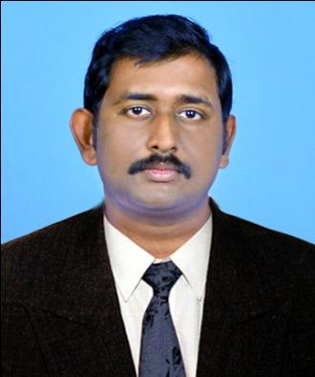

SYAM

Current Location: Dubai, UAE

Contact number: C/o 971504973598

Email: syam.378454@2freemail.com

CAREER OBJECTIVE

To be assigned a challenging role in Finance & Accounts that helps in utilization of my potential and provides me the opportunity to apply my skills to the mutual benefit of the organization and self.

WORK EXPERIENCE

Accountant:

Technical Resources Est , Dubai , UAE ( Oct 2016To Present)

Falcon Accounts Outsourcing, Kerala, India (Aug 2014 To Aug 2016)

JOB PROFILE

  - Prepare and review Vouchers, Quotation, LPO, Delivery note, Debit note, Credit note, invoices, Receipts, Payment vouchers and any other accounting documents.

- Handling Expense-Related Accounts

- Prepare periodical financial statements such as weekly, monthly, quarterly and yearly as per the instructions from the management.

- Preparing monthly MIS reports to provide management with an accurate timely perspective of forecasted financial positions.

- Provided financial status information by preparing special reports; completing special projects.

- Monitor and track obligations and expenditures for program and support functions throughout execution phase of annual operating budget.

- Control Petty Cash and monitor the cash movement
- payment Chasing from customers
- Report Presentation

- Ensure compliance with relevant laws and regulations and integrity of financial data

- Pass all Associated Final Entries

EDUCATIONAL QUALIFICATION

- Master of Business Administration (MBA- Finance &HR), MG University, India

- Bachelor of Commerce (B.Com), MG University, India

IT SKILLS

- MS Office

- Tally ERP 9, Peachtree

- Confident to do any Accounting Software

- Orion

PROFESSIONAL SKILLS

- Stress tolerance
- Leadership

- Communication Skill
- Hardworking
- Professionalism

PERSONAL DETAILS

Date of Birth

: 08/06/1990

Gender

: Male

Nationality

: Indian

Marital Status

: Single

Religion

: Hindu

Languages Known

: English, Malayalam, Tamil

Visa Status

: Resident Visa

REFERENCES

Reference will be provided on demand.

DECLARATION

I Here By declare that the information furnished above is True to be the best of my Knowledge

.

PLACE :AL KARAMA SYAM

DATE : FEB 2018

