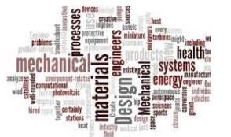
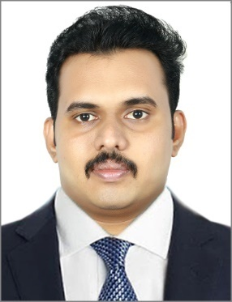
JOSEPH
Sharjah, UAE
C/o- Mobile :- +971501685421
Email :- joseph.378460@2freemail.com

SUMMARY
To become a part of the organization where I can apply my Knowledge enhances my skill and be
able to contribute growth and success of the organization. Two years of rich and comprehensive experience in Mechanical design and service engineering in India. Now looking for a suitable position with a company which offers genuine room for progression and where I can make a significant contribution

EXPERIENCE SUMMARY
- From September 2016- October 2017:COMMANDTECH & CAD IT PVT LTD,Trivandrum, Kerala, India
Designation : Mechanical Design Engineer
PROJECTS WORKED
- RIYADH METRO, SAUDI ARABIA
- EMIRATES HILL, DUBAI

JOB DESCRIPTION
- Mechanical Engineer focused on HVAC design, implementation and coordination at corporate level, with skills of drafting, implementing mechanical documents and drawings using Auto CAD.
- Preparing Heat load calculations, Duct sizing calculations, Pump head calculations, fan selection and chilled water pipe line sizing.
- Implementation of SMACNA rules in design calculations
- .Preparing duct routing, double line drafting, shop drawings
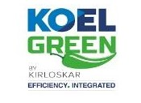
- FROM JULY 2015-AUGUST 2016:SREELAKSHMI DIESELS -Authorized Kirloskar Service Centre, Trivandrum, Kerala, India
Designation: Service Engineer
JOB DESCRIPTION

- Visiting client- site for scheduled maintenance, mechanical repair, installation, or replacementof Company products and spares
- Inspection of all operating parts to ensure proper operation within expected tolerance.
- Tune and troubleshoot equipment for proper operation by providing technicians with necessaryaction plans and check list.
- .Clearly and professionally interact with customer regarding status of the job performed.
- Perform maintenance on equipment as and when required and assist in establishing preventive maintenance schedules with customer
- .Providing training to end users on the proper use of the company’s products
- .Maintaining records of visit to client sites, issues, action plan, time spent and reporting trends in issues or customer suggestions to Service Manager
EDUCATIONAL QUALIFICATIONS
- Bachelors of Engineering : Mechanical Engineering, MG university, Kerala, India

CERTIFICATION
- Autodesk AUTOCAD 2017
SOFTWARE KNOWLEDGE
- Autocad
- Primavera
- HAP
- Solidedge
- McQuay duct sizer
- E20 Sheet
- MS Office Applications
SKILLS
- Great interpersonal skills.
- Good verbal and written communication skills
- Ability to work under time pressure
- Team player skills

PERSONAL DETAILS
- Languages Known :- English, Hindi, Malayalam,Tamil
- Marital Status :- Single
- Nationality :- Indian
- Religion :- Christian
- Visa Status :- Visiting visa
DECLARATION
I hereby declare that the above mentioned information is true to the best of my knowledge
and I hold the responsibility for the correctness of the above mentioned particulars

